
Practical No.: 11
Aim –
Demonstrate JavaScript timing events (setInterval, setTimeout, clearInterval) and ES6 modular code structure (import/export) by developing an interactive Countdown Timer and Class Scheduler application. Implement Case Study 1: TechNova Technical Workshop Ticket Booking System integrating multi-category registration, dynamic discount calculations, validation, and real-time order summaries, alongside interactive web portals for Smart India Hackathon (SIH) and Rakhi World e-commerce showcase.
Software/Tools Required –
VSCode
Chrome Browser
HTML5
CSS3
JavaScript (ES6 Modules)
Experiment Program Code – Countdown Timer & Class Scheduler
index.html
<!DOCTYPE html>
<html lang="en">
<head>
<meta charset="UTF-8">
<meta name="viewport" content="width=device-width, initial-scale=1.0">

<title>Countdown Timer & Class Scheduler</title>

<link rel="stylesheet" href="style.css">
</head>
<body>

<div class="container">

<h1>Countdown Timer</h1>
<p class="subtitle">Manage your study time efficiently!</p>

<!-- Countdown Timer -->
<section class="card">
<h2>Study Timer</h2>

<label for="minutes">Enter Minutes:</label>
<input type="number" id="minutes" min="1" value="5">

<div id="countdown">05:00</div>

<p id="status">Ready to start?</p>

<div class="buttons">
<button id="startBtn">Start</button>
<button id="pauseBtn">Pause</button>
<button id="resetBtn">Reset</button>
</div>
</section>

<!-- Class Scheduler -->
<section class="card">
<h2>Class Scheduler</h2>

<form id="scheduleForm">

<label for="className">Class Name:</label>
<input
type="text"
id="className"
placeholder="Enter class name"
required
>

<label for="classTime">Date and Time:</label>
<input type="datetime-local" id="classTime" required>

<button type="submit">Add Class</button>

</form>

<p id="message"></p>

<h3>Scheduled Classes</h3>
<div id="classList">No classes scheduled.</div>
</section>

</div>

<script type="module" src="main.js"></script>

</body>
</html>
style.css
* {
box-sizing: border-box;
}

body {
margin: 0;
padding: 20px;
font-family: Arial, sans-serif;
background: #edf3ff;
color: #243451;
}

.container {
max-width: 700px;
margin: auto;
}

h1 {
text-align: center;
color: #315fc4;
}

.subtitle {
text-align: center;
color: #64748b;
margin-bottom: 25px;
}

.card {
background: white;
padding: 25px;
margin-bottom: 22px;
border-radius: 15px;
box-shadow: 0 5px 18px rgba(30, 60, 100, 0.10);
}

h2 {
margin-top: 0;
color: #315fc4;
}

label {
display: block;
margin-top: 15px;
margin-bottom: 7px;
font-weight: bold;
}

input {
width: 100%;
padding: 11px;
border: 1px solid #cbd5e1;
border-radius: 7px;
font-size: 15px;
}

input:focus {
outline: 2px solid #a5bfff;
border-color: #315fc4;
}

#countdown {
text-align: center;
font-size: 65px;
font-weight: bold;
color: #315fc4;
margin: 22px 0 10px;
}

#status,
#message {
text-align: center;
color: #64748b;
min-height: 20px;
}

.buttons {
display: flex;
justify-content: center;
gap: 10px;
flex-wrap: wrap;
}

button {
padding: 11px 20px;
margin-top: 15px;
border: none;
border-radius: 7px;
background: #315fc4;
color: white;
font-size: 15px;
cursor: pointer;
}

button:hover {
background: #23489b;
}

#classList {
margin-top: 12px;
padding: 12px;
background: #f5f8ff;
border-radius: 8px;
overflow-wrap: anywhere;
}

.class-item {
padding: 12px 5px;
border-bottom: 1px solid #dbe4f3;
}

.class-item:last-child {
border-bottom: none;
}

.class-item strong {
display: block;
margin-bottom: 6px;
}

@media (max-width: 480px) {
body {
padding: 12px;
}

.card {
padding: 18px;
}

#countdown {
font-size: 48px;
}

button {
padding: 10px 14px;
}
}
timer.js
// Convert seconds into MM:SS format
export function formatTime(seconds) {
let minutes = Math.floor(seconds / 60);
let remainingSeconds = seconds % 60;

return String(minutes).padStart(2, "0") + ":" +
String(remainingSeconds).padStart(2, "0");
}

// Start the countdown
export function startCountdown(seconds, onTick, onComplete) {

let remaining = seconds;

onTick(remaining);

const intervalId = setInterval(function () {

remaining--;

onTick(remaining);

if (remaining <= 0) {
clearInterval(intervalId);
onComplete();
}

}, 1000);

return intervalId;
}

// Demonstration of setTimeout()
export function notifyAfterDelay(callback) {

setTimeout(function () {
callback();
}, 1000);

}
main.js
import {
formatTime,
startCountdown,
notifyAfterDelay
} from "./timer.js";

const minutesInput = document.getElementById("minutes");
const countdown = document.getElementById("countdown");
const status = document.getElementById("status");

const startBtn = document.getElementById("startBtn");
const pauseBtn = document.getElementById("pauseBtn");
const resetBtn = document.getElementById("resetBtn");

let remainingSeconds = Number(minutesInput.value) * 60;
let intervalId = null;
let isRunning = false;

// Display the timer
function updateDisplay() {
countdown.textContent = formatTime(remainingSeconds);
}

// Stop the timer
function stopTimer() {
if (intervalId !== null) {
clearInterval(intervalId);
intervalId = null;
}

isRunning = false;
}

// Start button
startBtn.addEventListener("click", function () {

if (isRunning) {
return;
}

if (remainingSeconds <= 0) {
const minutes = Number(minutesInput.value);

if (!Number.isFinite(minutes) || minutes < 1) {
status.textContent = "Enter at least 1 minute.";
return;
}

remainingSeconds = Math.floor(minutes * 60);
}

isRunning = true;
status.textContent = "Timer started! Focus on your work.";

intervalId = startCountdown(
remainingSeconds,

function (seconds) {
remainingSeconds = seconds;
updateDisplay();
},

function () {
remainingSeconds = 0;
isRunning = false;
intervalId = null;

status.textContent = "Time is up! Take a break.";

// Use setTimeout() for delayed notification
notifyAfterDelay(function () {
alert("Countdown completed!");
});
}
);

});

// Pause button
pauseBtn.addEventListener("click", function () {

if (isRunning) {
stopTimer();
status.textContent = "Timer paused.";
}

});

// Reset button
resetBtn.addEventListener("click", function () {

stopTimer();

const minutes = Number(minutesInput.value);

if (Number.isFinite(minutes) && minutes >= 1) {
remainingSeconds = Math.floor(minutes * 60);
} else {
remainingSeconds = 300;
}

updateDisplay();
status.textContent = "Timer reset.";

});

// Update timer when duration changes
minutesInput.addEventListener("change", function () {

if (isRunning) {
return;
}

const minutes = Number(minutesInput.value);

if (Number.isFinite(minutes) && minutes >= 1) {
remainingSeconds = Math.floor(minutes * 60);
updateDisplay();
status.textContent = "Ready to start?";
} else {
status.textContent = "Enter at least 1 minute.";
}

});

// ---------------- CLASS SCHEDULER ----------------

const scheduleForm = document.getElementById("scheduleForm");
const classNameInput = document.getElementById("className");
const classTimeInput = document.getElementById("classTime");

const classList = document.getElementById("classList");
const message = document.getElementById("message");

// Load saved classes from localStorage
let classes = JSON.parse(
localStorage.getItem("scheduledClasses") || "[]"
);

// Display scheduled classes
function displayClasses() {

classList.replaceChildren();

if (classes.length === 0) {
classList.textContent = "No classes scheduled.";
return;
}

classes.sort(function (a, b) {
return new Date(a.time) - new Date(b.time);
});

classes.forEach(function (item) {

const div = document.createElement("div");
div.className = "class-item";

const title = document.createElement("strong");
title.textContent = item.name;

const time = document.createElement("p");
time.textContent = new Date(item.time).toLocaleString();

div.appendChild(title);
div.appendChild(time);

classList.appendChild(div);

});

}

// Add a new class
scheduleForm.addEventListener("submit", function (event) {

event.preventDefault();

const name = classNameInput.value.trim();
const time = classTimeInput.value;

if (!name || !time) {
message.textContent = "Please fill in all fields.";
return;
}

if (new Date(time).getTime() <= Date.now()) {
message.textContent = "Please select a future date and time.";
return;
}

classes.push({
name: name,
time: time
});

// Save classes in browser storage
localStorage.setItem(
"scheduledClasses",
JSON.stringify(classes)
);

displayClasses();

message.textContent = "Class added successfully!";

scheduleForm.reset();

});

// Initial display
updateDisplay();
displayClasses();
Output –
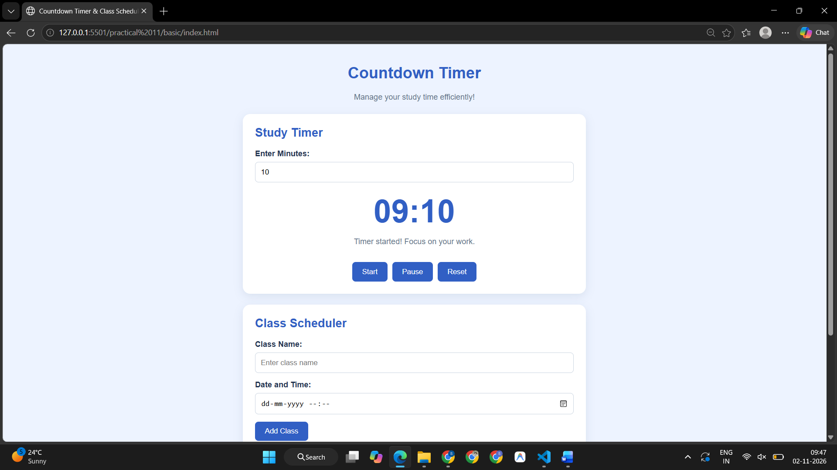
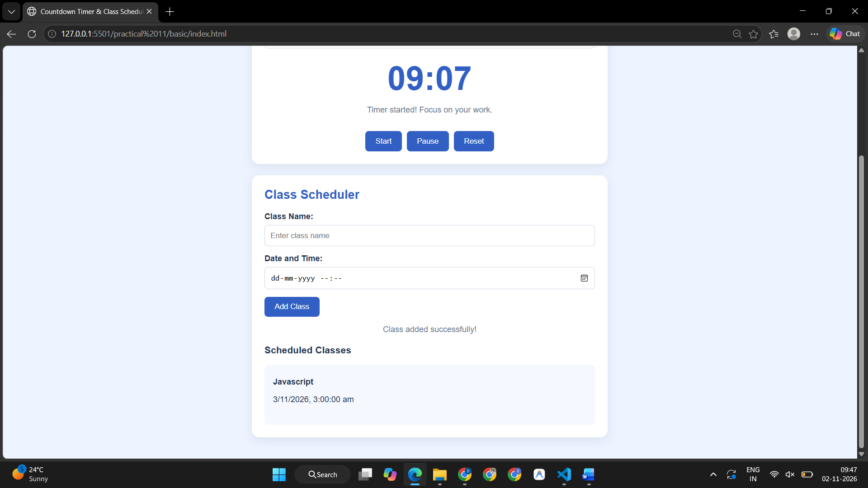
Case Study Title –
Case Study 1: TechNova Technical Workshop Booking System with Dynamic Ticket Calculation and Validation
Case Study Program Code –
index.html
<!DOCTYPE html>
<html lang="en">
<head>
<meta charset="UTF-8">

<meta name="viewport" content="width=device-width, initial-scale=1.0">

<title>TechNova | Workshop Ticket Booking</title>

<!-- External CSS -->
<link rel="stylesheet" href="style.css">

<!-- Internal JavaScript: small page-level welcome action -->
<script>
console.log("Technical Workshop Booking page is loading...");

function showWelcomeMessage() {
console.log("Welcome to TechNova Technical Workshop!");
}

showWelcomeMessage();
</script>
</head>

<body>

<!-- Header -->
<header class="header">
<div class="logo">
<span class="logo-icon">⚡</span>
<div>
<h2>TechNova</h2>
<small>Learn • Build • Innovate</small>
</div>
</div>

<nav>
<a href="#workshop">Workshop</a>
<a href="#booking">Book Ticket</a>
<a href="#summary">Summary</a>

<button id="themeToggle" class="theme-btn" type="button">
🌙
</button>
</nav>
</header>

<!-- Hero Section -->
<section class="hero" id="workshop">

<div class="hero-content">

<span class="badge">🚀 TECHNICAL WORKSHOP 2026</span>

<h1>
Build Your Future
<span>With Technology.</span>
</h1>

<p>
Join industry experts for a hands-on technical workshop
covering AI, Web Development, Cloud and emerging technologies.
</p>

<div class="hero-info">

<div>
<span>📅</span>
<div>
<small>Date</small>
<strong>18 October 2026</strong>
</div>
</div>

<div>
<span>📍</span>
<div>
<small>Venue</small>
<strong>TechNova Auditorium</strong>
</div>
</div>

<div>
<span>⏰</span>
<div>
<small>Duration</small>
<strong>10:00 AM – 5:00 PM</strong>
</div>
</div>

</div>

<a href="#booking" class="primary-btn">
Book Your Ticket →
</a>

</div>

<div class="hero-visual">
<div class="floating-card card-one">
<span>🤖</span>
<div>
<strong>AI & ML</strong>
<small>Hands-on Session</small>
</div>
</div>

<div class="tech-circle">
<div class="circle-inner">
<span>💻</span>
<strong>TECH</strong>
<small>WORKSHOP</small>
</div>
</div>

<div class="floating-card card-two">
<span>☁️</span>
<div>
<strong>Cloud</strong>
<small>Industry Experts</small>
</div>
</div>
</div>

</section>

<!-- Workshop Highlights -->
<section class="highlights">

<div class="section-heading">
<span class="mini-label">WHAT YOU'LL GET</span>
<h2>More Than Just a Workshop</h2>
<p>
Everything you need for a productive and practical learning experience.
</p>
</div>

<div class="highlight-grid">

<div class="highlight-card">
<div class="highlight-icon">🎓</div>
<h3>Expert Sessions</h3>
<p>Learn directly from professionals and experienced speakers.</p>
</div>

<div class="highlight-card">
<div class="highlight-icon">🧑‍💻</div>
<h3>Hands-on Labs</h3>
<p>Practice concepts through real-world technical activities.</p>
</div>

<div class="highlight-card">
<div class="highlight-icon">📜</div>
<h3>Certificate</h3>
<p>Receive a certificate of participation after attending.</p>
</div>

<div class="highlight-card">
<div class="highlight-icon">🤝</div>
<h3>Networking</h3>
<p>Connect with students, developers and industry professionals.</p>
</div>

</div>

</section>

<!-- Booking Section -->
<main id="booking" class="booking-section">

<div class="section-heading">
<span class="mini-label">REGISTRATION</span>
<h2>Reserve Your Workshop Ticket</h2>
<p>Fill in your details and customize your workshop experience.</p>
</div>

<form id="bookingForm" novalidate>

<!-- Personal Details -->
<div class="form-card">

<div class="form-card-heading">
<div class="step-number">01</div>
<div>
<h3>Your Details</h3>
<p>Tell us who will be attending.</p>
</div>
</div>

<div class="form-grid">

<div class="form-group">
<label for="fullName">
Full Name <span>*</span>
</label>

<input
type="text"
id="fullName"
placeholder="e.g. Sanskruti Gorle"
autocomplete="name"
>

<small class="error-message" id="fullNameError"></small>
</div>

<div class="form-group">
<label for="email">
Email Address <span>*</span>
</label>

<input
type="email"
id="email"
placeholder="e.g. student@gmail.com"
autocomplete="email"
>

<small class="error-message" id="emailError"></small>
</div>

<div class="form-group">
<label for="phone">
Phone Number <span>*</span>
</label>

<input
type="tel"
id="phone"
placeholder="10-digit mobile number"
maxlength="10"
>

<small class="error-message" id="phoneError"></small>
</div>

<div class="form-group">
<label for="studentId">
Student ID / PRN <span>*</span>
</label>

<input
type="text"
id="studentId"
placeholder="e.g. 24070521025"
>

<small class="error-message" id="studentIdError"></small>
</div>

<div class="form-group full-width">
<label for="college">
College / Organization <span>*</span>
</label>

<input
type="text"
id="college"
placeholder="Enter your college or organization"
>

<small class="error-message" id="collegeError"></small>
</div>

</div>

</div>

<!-- Ticket Selection -->
<div class="form-card">

<div class="form-card-heading">
<div class="step-number">02</div>

<div>
<h3>Choose Your Ticket</h3>
<p>Select the ticket that suits your workshop experience.</p>
</div>
</div>

<div class="ticket-grid">

<label class="ticket-option">

<input
type="radio"
name="ticket"
value="student"
data-price="499"
checked
>

<div class="ticket-content">
<div class="ticket-top">
<span class="ticket-icon">🎓</span>
<span class="recommended">POPULAR</span>
</div>

<h3>Student Pass</h3>

<p>
Full workshop access designed for students.
</p>

<strong>₹499</strong>
</div>

</label>

<label class="ticket-option">

<input
type="radio"
name="ticket"
value="professional"
data-price="999"
>

<div class="ticket-content">
<div class="ticket-top">
<span class="ticket-icon">💼</span>
</div>

<h3>Professional Pass</h3>

<p>
Workshop access with professional networking benefits.
</p>

<strong>₹999</strong>
</div>

</label>

<label class="ticket-option">

<input
type="radio"
name="ticket"
value="premium"
data-price="1499"
>

<div class="ticket-content">
<div class="ticket-top">
<span class="ticket-icon">⭐</span>
</div>

<h3>Premium Pass</h3>

<p>
Premium seating, kit and exclusive networking access.
</p>

<strong>₹1499</strong>
</div>

</label>

</div>

<div class="small-grid">

<div class="form-group">
<label for="quantity">
Number of Tickets
</label>

<select id="quantity">

<option value="1">1 Ticket</option>
<option value="2">2 Tickets</option>
<option value="3">3 Tickets</option>
<option value="4">4 Tickets</option>
<option value="5">5 Tickets</option>

</select>
</div>

<div class="form-group">
<label for="session">
Preferred Session <span>*</span>
</label>

<select id="session">

<option value="">
Select a session
</option>

<option value="ai">
AI & Machine Learning
</option>

<option value="web">
Modern Web Development
</option>

<option value="cloud">
Cloud & DevOps
</option>

<option value="cyber">
Cybersecurity Basics
</option>

</select>

<small class="error-message" id="sessionError"></small>

</div>

</div>

</div>

<!-- Add-ons -->
<div class="form-card">

<div class="form-card-heading">
<div class="step-number">03</div>

<div>
<h3>Customize Your Experience</h3>
<p>Add optional workshop benefits.</p>
</div>
</div>

<div class="addon-list">

<label class="addon">

<input
type="checkbox"
class="addon-checkbox"
value="Learning Kit"
data-price="199"
>

<div class="addon-info">
<span class="addon-icon">📚</span>

<div>
<strong>Learning Kit</strong>
<small>Notebook, resources and workshop material</small>
</div>
</div>

<strong class="addon-price">+₹199</strong>

</label>

<label class="addon">

<input
type="checkbox"
class="addon-checkbox"
value="Lunch"
data-price="149"
>

<div class="addon-info">
<span class="addon-icon">🍱</span>

<div>
<strong>Lunch</strong>
<small>Vegetarian lunch and refreshments</small>
</div>
</div>

<strong class="addon-price">+₹149</strong>

</label>

<label class="addon">

<input
type="checkbox"
class="addon-checkbox"
value="Certificate Upgrade"
data-price="99"
>

<div class="addon-info">
<span class="addon-icon">🏆</span>

<div>
<strong>Certificate Upgrade</strong>
<small>Premium printed certificate</small>
</div>
</div>

<strong class="addon-price">+₹99</strong>

</label>

</div>

<div class="preference-row">

<label for="foodPreference">
🍽️ Food Preference
</label>

<select id="foodPreference">

<option value="Not Required">
Not Required
</option>

<option value="Vegetarian">
Vegetarian
</option>

<option value="Jain">
Jain
</option>

</select>

</div>

</div>

<!-- Additional Attendees -->
<div class="form-card">

<div class="form-card-heading">
<div class="step-number">04</div>

<div>
<h3>Additional Attendees</h3>
<p>Add companions attending with you.</p>
</div>
</div>

<div class="attendee-input">

<input
type="text"
id="attendeeName"
placeholder="Enter attendee name"
>

<button
type="button"
id="addAttendee"
class="secondary-btn"
>
+ Add Attendee
</button>

</div>

<small class="helper-text">
You can edit or remove an attendee before confirming your booking.
</small>

<div id="attendeeList" class="attendee-list">
<!-- Dynamic attendees appear here -->
</div>

</div>

<!-- Promo -->
<div class="form-card">

<div class="form-card-heading">
<div class="step-number">05</div>

<div>
<h3>Promo Code</h3>
<p>Have a workshop discount code?</p>
</div>
</div>

<div class="promo-row">

<input
type="text"
id="promoCode"
placeholder="Enter promo code"
maxlength="20"
>

<button
type="button"
id="applyPromo"
class="secondary-btn"
>
Apply Code
</button>

</div>

<small id="promoMessage" class="promo-message"></small>

</div>

<!-- Booking Summary -->
<div class="summary-card" id="summary">

<div class="summary-heading">

<div>
<span class="mini-label">ORDER SUMMARY</span>
<h2>Your Workshop Booking</h2>
</div>

<span id="bookingStatus" class="status-badge">
Draft
</span>

</div>

<div id="selectedItems" class="selected-items">
<!-- Generated dynamically -->
</div>

<div class="price-breakdown">

<div>
<span>Ticket Subtotal</span>
<strong id="ticketSubtotal">₹499</strong>
</div>

<div>
<span>Add-ons</span>
<strong id="addonSubtotal">₹0</strong>
</div>

<div id="discountRow" class="discount-row hidden">
<span>Discount</span>
<strong id="discountAmount">-₹0</strong>
</div>

<div class="total-row">
<span>Total</span>
<strong id="grandTotal">₹499</strong>
</div>

</div>

<div class="terms">

<label>

<input
type="checkbox"
id="terms"
>

<span>
I confirm that the information provided is correct and
I agree to the workshop booking terms.
</span>

</label>

<small class="error-message" id="termsError"></small>

</div>

<div class="form-actions">

<button
type="reset"
class="reset-btn"
>
Reset
</button>

<button
type="submit"
class="primary-btn"
>
Confirm Booking →
</button>

</div>

</div>

</form>

</main>

<!-- Confirmation Modal -->
<div
id="confirmationModal"
class="modal hidden"
>

<div class="modal-content">

<button
id="closeModal"
class="close-modal"
type="button"
>
×
</button>

<div class="success-icon">
✓
</div>

<span class="mini-label">BOOKING CONFIRMED</span>

<h2>You're Registered! 🎉</h2>

<p id="confirmationMessage">
Your workshop ticket has been successfully booked.
</p>

<div class="registration-box">

<small>REGISTRATION ID</small>

<strong id="registrationId">
TN-000000
</strong>

</div>

<div class="confirmation-details" id="confirmationDetails">
<!-- Dynamic confirmation details -->
</div>

<button
id="doneButton"
type="button"
class="primary-btn full-btn"
>
Done
</button>

</div>

</div>

<!-- Footer -->
<footer>

<div>
<strong>TechNova</strong>
<span>Technical Workshop 2026</span>
</div>

<p>
Learn. Build. Innovate.
</p>

<small>
© 2026 TechNova Workshop
</small>

</footer>

<!-- External JavaScript -->
<script src="script.js"></script>

</body>
</html>
style.css
/* ================================
TECHNOVA WORKSHOP
PRACTICAL 10 - Q1
================================ */

* {
margin: 0;
padding: 0;
box-sizing: border-box;
}

:root {
--primary: #6c5ce7;
--primary-dark: #5142c5;
--secondary: #00b894;

--bg: #f6f7fb;
--surface: #ffffff;
--surface-soft: #f1f2f8;

--text: #202033;
--muted: #73758a;

--border: #e3e4ed;

--danger: #e74c3c;
--success: #159957;

--shadow: 0 15px 45px rgba(38, 35, 80, 0.08);
}

body {
font-family:
Inter,
"Segoe UI",
Arial,
sans-serif;

background: var(--bg);
color: var(--text);

line-height: 1.6;

transition:
background 0.3s ease,
color 0.3s ease;
}

html {
scroll-behavior: smooth;
}

button,
input,
select {
font: inherit;
}

/* ================================
HEADER
================================ */

.header {
position: sticky;
top: 0;

z-index: 100;

display: flex;
justify-content: space-between;
align-items: center;

padding: 16px 7%;

background: rgba(255, 255, 255, 0.92);

backdrop-filter: blur(15px);

border-bottom: 1px solid var(--border);
}

.logo {
display: flex;
align-items: center;
gap: 12px;
}

.logo-icon {
width: 44px;
height: 44px;

display: grid;
place-items: center;

border-radius: 13px;

background: linear-gradient(
135deg,
var(--primary),
#9b8cff
);

color: white;

font-size: 21px;

box-shadow: 0 8px 20px rgba(108, 92, 231, 0.25);
}

.logo h2 {
font-size: 18px;
line-height: 1.1;
}

.logo small {
color: var(--muted);
font-size: 10px;
}

nav {
display: flex;
align-items: center;
gap: 28px;
}

nav a {
color: var(--text);

text-decoration: none;

font-size: 14px;
font-weight: 600;

transition: 0.2s;
}

nav a:hover {
color: var(--primary);
}

.theme-btn {
border: none;

width: 40px;
height: 40px;

border-radius: 50%;

background: var(--surface-soft);

cursor: pointer;

transition: 0.2s;
}

.theme-btn:hover {
transform: rotate(15deg);
}

/* ================================
HERO
================================ */

.hero {
min-height: 600px;

display: flex;
align-items: center;
justify-content: space-between;

gap: 50px;

padding: 80px 8%;

overflow: hidden;

background:
radial-gradient(
circle at 80% 30%,
rgba(108, 92, 231, 0.13),
transparent 30%
);
}

.hero-content {
max-width: 700px;
}

.badge,
.mini-label {
display: inline-block;

color: var(--primary);

font-size: 11px;

font-weight: 800;

letter-spacing: 1.5px;
}

.badge {
padding: 8px 14px;

border-radius: 30px;

background: rgba(108, 92, 231, 0.1);

margin-bottom: 18px;
}

.hero h1 {
font-size: clamp(42px, 6vw, 76px);

line-height: 1.02;

letter-spacing: -3px;

margin-bottom: 25px;
}

.hero h1 span {
display: block;

color: var(--primary);
}

.hero-content > p {
max-width: 600px;

color: var(--muted);

font-size: 17px;

margin-bottom: 35px;
}

.hero-info {
display: flex;
flex-wrap: wrap;

gap: 18px;

margin-bottom: 35px;
}

.hero-info > div {
display: flex;
align-items: center;

gap: 10px;

padding: 13px 15px;

border: 1px solid var(--border);

border-radius: 14px;

background: var(--surface);
}

.hero-info span {
font-size: 20px;
}

.hero-info small,
.hero-info strong {
display: block;
}

.hero-info small {
color: var(--muted);

font-size: 10px;
}

.hero-info strong {
font-size: 12px;
}

.primary-btn {
display: inline-flex;

justify-content: center;
align-items: center;

gap: 8px;

padding: 14px 24px;

border: none;

border-radius: 12px;

background: linear-gradient(
135deg,
var(--primary),
#8174ee
);

color: white;

font-weight: 700;

text-decoration: none;

cursor: pointer;

box-shadow:
0 10px 25px rgba(108, 92, 231, 0.2);

transition:
transform 0.2s,
box-shadow 0.2s;
}

.primary-btn:hover {
transform: translateY(-2px);

box-shadow:
0 14px 30px rgba(108, 92, 231, 0.3);
}

.hero-visual {
width: 400px;
height: 400px;

position: relative;

display: grid;
place-items: center;
}

.tech-circle {
width: 270px;
height: 270px;

display: grid;
place-items: center;

border-radius: 50%;

background:
radial-gradient(
circle,
rgba(108, 92, 231, 0.2),
rgba(108, 92, 231, 0.05)
);

border: 1px solid rgba(108, 92, 231, 0.2);
}

.circle-inner {
width: 190px;
height: 190px;

display: flex;
flex-direction: column;

justify-content: center;
align-items: center;

border-radius: 50%;

background: var(--surface);

box-shadow: var(--shadow);
}

.circle-inner span {
font-size: 48px;
}

.circle-inner strong {
font-size: 22px;

color: var(--primary);
}

.circle-inner small {
color: var(--muted);

letter-spacing: 3px;

font-size: 9px;
}

.floating-card {
position: absolute;

display: flex;
align-items: center;

gap: 10px;

padding: 13px 17px;

border-radius: 15px;

background: var(--surface);

box-shadow: var(--shadow);

border: 1px solid var(--border);
}

.floating-card > span {
font-size: 25px;
}

.floating-card strong,
.floating-card small {
display: block;
}

.floating-card strong {
font-size: 12px;
}

.floating-card small {
color: var(--muted);

font-size: 10px;
}

.card-one {
top: 35px;
left: 0;
}

.card-two {
right: 0;
bottom: 40px;
}

/* ================================
GENERAL SECTIONS
================================ */

.highlights,
.booking-section {
padding: 85px 8%;
}

.section-heading {
text-align: center;

max-width: 700px;

margin: 0 auto 45px;
}

.section-heading h2 {
font-size: 36px;

margin: 7px 0 10px;
}

.section-heading p {
color: var(--muted);
}

.highlight-grid {
display: grid;

grid-template-columns:
repeat(4, 1fr);

gap: 18px;
}

.highlight-card {
padding: 28px;

background: var(--surface);

border: 1px solid var(--border);

border-radius: 20px;

transition: 0.25s;
}

.highlight-card:hover {
transform: translateY(-5px);

box-shadow: var(--shadow);
}

.highlight-icon {
width: 50px;
height: 50px;

display: grid;
place-items: center;

border-radius: 14px;

background: var(--surface-soft);

font-size: 24px;

margin-bottom: 18px;
}

.highlight-card h3 {
margin-bottom: 7px;
}

.highlight-card p {
color: var(--muted);

font-size: 13px;
}

/* ================================
FORM
================================ */

.booking-section {
background:
linear-gradient(
180deg,
var(--bg),
#eef0f8
);
}

.form-card,
.summary-card {
max-width: 1050px;

margin: 0 auto 22px;

background: var(--surface);

border: 1px solid var(--border);

border-radius: 22px;

padding: 30px;

box-shadow: 0 8px 30px rgba(40, 40, 80, 0.04);
}

.form-card-heading {
display: flex;

align-items: center;

gap: 14px;

margin-bottom: 25px;
}

.step-number {
width: 45px;
height: 45px;

flex-shrink: 0;

display: grid;
place-items: center;

border-radius: 13px;

background: rgba(108, 92, 231, 0.1);

color: var(--primary);

font-size: 12px;

font-weight: 800;
}

.form-card-heading h3 {
font-size: 19px;
}

.form-card-heading p {
color: var(--muted);

font-size: 12px;
}

.form-grid {
display: grid;

grid-template-columns:
repeat(2, 1fr);

gap: 20px;
}

.full-width {
grid-column: 1 / -1;
}

.form-group label {
display: block;

margin-bottom: 7px;

font-size: 13px;

font-weight: 700;
}

.form-group label span {
color: var(--danger);
}

input,
select {
width: 100%;

border: 1px solid var(--border);

background: var(--surface);

color: var(--text);

padding: 13px 14px;

border-radius: 11px;

outline: none;

transition:
border 0.2s,
box-shadow 0.2s,
background 0.2s;
}

input::placeholder {
color: #aaaabd;
}

input:focus,
select:focus {
border-color: var(--primary);

box-shadow:
0 0 0 4px rgba(108, 92, 231, 0.08);
}

.input-error {
border-color: var(--danger) !important;

box-shadow:
0 0 0 4px rgba(231, 76, 60, 0.08) !important;
}

.input-success {
border-color: var(--success) !important;
}

.error-message {
display: block;

min-height: 17px;

margin-top: 4px;

color: var(--danger);

font-size: 11px;
}

/* ================================
TICKETS
================================ */

.ticket-grid {
display: grid;

grid-template-columns:
repeat(3, 1fr);

gap: 15px;

margin-bottom: 22px;
}

.ticket-option {
cursor: pointer;
}

.ticket-option input {
position: absolute;

opacity: 0;

pointer-events: none;
}

.ticket-content {
height: 100%;

padding: 22px;

border: 2px solid var(--border);

border-radius: 17px;

transition: 0.2s;
}

.ticket-option input:checked + .ticket-content {
border-color: var(--primary);

background:
rgba(108, 92, 231, 0.05);

box-shadow:
0 8px 25px rgba(108, 92, 231, 0.08);
}

.ticket-top {
display: flex;

justify-content: space-between;

margin-bottom: 18px;
}

.ticket-icon {
font-size: 27px;
}

.recommended {
padding: 5px 8px;

background: rgba(0, 184, 148, 0.1);

color: var(--secondary);

border-radius: 7px;

font-size: 8px;

font-weight: 800;
}

.ticket-content h3 {
margin-bottom: 7px;
}

.ticket-content p {
min-height: 48px;

color: var(--muted);

font-size: 12px;

margin-bottom: 12px;
}

.ticket-content > strong {
color: var(--primary);

font-size: 21px;
}

.small-grid {
display: grid;

grid-template-columns:
repeat(2, 1fr);

gap: 20px;
}

/* ================================
ADDONS
================================ */

.addon-list {
display: grid;

gap: 10px;
}

.addon {
display: flex;

align-items: center;

gap: 15px;

padding: 15px;

border: 1px solid var(--border);

border-radius: 14px;

cursor: pointer;

transition: 0.2s;
}

.addon:hover {
border-color: var(--primary);
}

.addon input {
width: auto;
}

.addon-info {
display: flex;

align-items: center;

gap: 12px;

flex: 1;
}

.addon-icon {
width: 38px;
height: 38px;

display: grid;
place-items: center;

border-radius: 10px;

background: var(--surface-soft);
}

.addon-info strong,
.addon-info small {
display: block;
}

.addon-info small {
color: var(--muted);

font-size: 11px;
}

.addon-price {
color: var(--primary);

font-size: 13px;
}

.preference-row {
display: flex;

align-items: center;

justify-content: space-between;

gap: 20px;

margin-top: 20px;

padding-top: 20px;

border-top: 1px solid var(--border);
}

.preference-row select {
max-width: 250px;
}

/* ================================
ATTENDEES
================================ */

.attendee-input {
display: flex;

gap: 10px;
}

.secondary-btn {
border: 1px solid var(--primary);

background: rgba(108, 92, 231, 0.07);

color: var(--primary);

padding: 12px 18px;

border-radius: 10px;

font-weight: 700;

cursor: pointer;

white-space: nowrap;

transition: 0.2s;
}

.secondary-btn:hover {
background: var(--primary);

color: white;
}

.helper-text {
display: block;

margin-top: 8px;

color: var(--muted);

font-size: 11px;
}

.attendee-list {
display: grid;

gap: 9px;

margin-top: 18px;
}

.attendee-item {
display: flex;

align-items: center;

justify-content: space-between;

gap: 10px;

padding: 12px 14px;

border-radius: 11px;

background: var(--surface-soft);
}

.attendee-name {
font-size: 13px;

font-weight: 600;
}

.attendee-actions {
display: flex;

gap: 7px;
}

.attendee-actions button {
border: none;

padding: 6px 10px;

border-radius: 7px;

cursor: pointer;

font-size: 11px;
}

.edit-btn {
background: rgba(108, 92, 231, 0.12);

color: var(--primary);
}

.delete-btn {
background: rgba(231, 76, 60, 0.1);

color: var(--danger);
}

/* ================================
PROMO
================================ */

.promo-row {
display: flex;

gap: 10px;
}

.promo-message {
display: block;

margin-top: 8px;

font-size: 12px;
}

.promo-success {
color: var(--success);
}

.promo-error {
color: var(--danger);
}

/* ================================
SUMMARY
================================ */

.summary-card {
margin-top: 30px;

border: 2px solid rgba(108, 92, 231, 0.15);
}

.summary-heading {
display: flex;

justify-content: space-between;

align-items: center;

margin-bottom: 25px;
}

.summary-heading h2 {
margin-top: 5px;
}

.status-badge {
padding: 7px 12px;

border-radius: 30px;

background: rgba(255, 193, 7, 0.12);

color: #b07a00;

font-size: 10px;

font-weight: 800;
}

.selected-items {
display: grid;

gap: 10px;

margin-bottom: 20px;
}

.selected-item {
display: flex;

justify-content: space-between;

align-items: center;

padding: 13px 15px;

background: var(--surface-soft);

border-radius: 11px;

font-size: 13px;
}

.selected-item span {
color: var(--muted);
}

.price-breakdown {
border-top: 1px solid var(--border);
}

.price-breakdown > div {
display: flex;

justify-content: space-between;

padding: 11px 0;

font-size: 13px;
}

.discount-row {
color: var(--success);
}

.hidden {
display: none !important;
}

.total-row {
margin-top: 8px;

padding-top: 17px !important;

border-top: 1px solid var(--border);

font-size: 20px !important;
}

.total-row strong {
color: var(--primary);

font-size: 24px;
}

.terms {
margin-top: 20px;

padding: 15px;

background: var(--surface-soft);

border-radius: 12px;
}

.terms label {
display: flex;

align-items: flex-start;

gap: 10px;

font-size: 12px;

cursor: pointer;
}

.terms input {
width: auto;

margin-top: 4px;
}

.form-actions {
display: flex;

justify-content: flex-end;

gap: 12px;

margin-top: 25px;
}

.reset-btn {
padding: 13px 22px;

border: 1px solid var(--border);

background: transparent;

color: var(--muted);

border-radius: 11px;

cursor: pointer;

font-weight: 700;
}

.reset-btn:hover {
background: var(--surface-soft);
}

/* ================================
MODAL
================================ */

.modal {
position: fixed;

inset: 0;

z-index: 500;

display: grid;

place-items: center;

padding: 20px;

background:
rgba(15, 15, 30, 0.65);

backdrop-filter: blur(8px);
}

.modal.hidden {
display: none;
}

.modal-content {
position: relative;

width: min(500px, 100%);

padding: 40px;

text-align: center;

background: var(--surface);

border-radius: 25px;

box-shadow:
0 30px 80px rgba(0, 0, 0, 0.25);
}

.close-modal {
position: absolute;

right: 18px;
top: 15px;

width: 35px;
height: 35px;

border: none;

border-radius: 50%;

background: var(--surface-soft);

color: var(--muted);

font-size: 24px;

cursor: pointer;
}

.success-icon {
width: 70px;
height: 70px;

display: grid;
place-items: center;

margin: 0 auto 20px;

border-radius: 50%;

background: rgba(21, 153, 87, 0.12);

color: var(--success);

font-size: 35px;

font-weight: bold;
}

.modal-content h2 {
margin: 8px 0;

font-size: 28px;
}

.modal-content > p {
color: var(--muted);

font-size: 13px;

margin-bottom: 22px;
}

.registration-box {
padding: 16px;

background: var(--surface-soft);

border-radius: 13px;

margin-bottom: 15px;
}

.registration-box small,
.registration-box strong {
display: block;
}

.registration-box small {
color: var(--muted);

font-size: 9px;

letter-spacing: 2px;
}

.registration-box strong {
margin-top: 5px;

color: var(--primary);

font-size: 22px;

letter-spacing: 2px;
}

.confirmation-details {
display: grid;

gap: 5px;

margin-bottom: 20px;

color: var(--muted);

font-size: 12px;
}

.full-btn {
width: 100%;
}

/* ================================
FOOTER
================================ */

footer {
display: flex;

justify-content: space-between;

align-items: center;

gap: 20px;

padding: 25px 8%;

background: #171625;

color: white;
}

footer strong,
footer span {
display: block;
}

footer span,
footer small {
color: #9694a8;

font-size: 11px;
}

footer p {
color: #c9c7d8;

font-size: 12px;
}

/* ================================
DARK MODE
================================ */

body.dark-mode {
--bg: #11111a;

--surface: #1a1a27;

--surface-soft: #242433;

--text: #f2f2fa;

--muted: #a2a1b4;

--border: #303043;
}

body.dark-mode .header {
background: rgba(17, 17, 26, 0.9);
}

body.dark-mode .booking-section {
background: #11111a;
}

body.dark-mode .ticket-content {
background: #1a1a27;
}

body.dark-mode .hero {
background:
radial-gradient(
circle at 80% 30%,
rgba(108, 92, 231, 0.2),
transparent 30%
);
}

/* ================================
RESPONSIVE
================================ */

@media (max-width: 950px) {

.hero {
padding-top: 55px;

flex-direction: column;

text-align: center;
}

.hero-content {
max-width: 750px;
}

.hero-content > p {
margin-left: auto;
margin-right: auto;
}

.hero-info {
justify-content: center;
}

.hero-visual {
width: 350px;
}

.highlight-grid {
grid-template-columns:
repeat(2, 1fr);
}

.ticket-grid {
grid-template-columns:
1fr;
}

}

@media (max-width: 700px) {

.header {
padding: 13px 5%;
}

nav a {
display: none;
}

.hero,
.highlights,
.booking-section {
padding-left: 5%;
padding-right: 5%;
}

.hero h1 {
font-size: 45px;

letter-spacing: -2px;
}

.hero-info {
flex-direction: column;
}

.hero-info > div {
justify-content: flex-start;
}

.highlight-grid,
.form-grid,
.small-grid {
grid-template-columns: 1fr;
}

.full-width {
grid-column: auto;
}

.form-card,
.summary-card {
padding: 20px;

border-radius: 17px;
}

.attendee-input,
.promo-row {
flex-direction: column;
}

.preference-row {
flex-direction: column;

align-items: stretch;
}

.preference-row select {
max-width: none;
}

.form-actions {
flex-direction: column-reverse;
}

.form-actions button {
width: 100%;
}

footer {
flex-direction: column;

text-align: center;
}

}
script.js
/* =====================================================
TECHNOVA TECHNICAL WORKSHOP BOOKING
PRACTICAL 10 - Q1

Concepts integrated from Practical 1 to 9:
P1 -> console, external JS, user information
P2 -> var, let, const, template literals, destructuring
P3 -> conditions and validation
P4 -> functions, scope, closure, try-catch
P5 -> arrays, objects, map, filter, find, reduce, includes
P6 -> strings and regular expressions
P7 -> DOM traversal and dynamic DOM manipulation
P8 -> events
P9 -> localStorage and sessionStorage
===================================================== */

/* =====================================================
P1 - CONSOLE METHODS
===================================================== */

console.log("=================================");
console.log("TechNova Workshop Booking Started");
console.log("=================================");

console.info("JavaScript file loaded successfully.");

// Small user information object
const applicationInfo = {
application: "Technical Workshop Ticket Booking",
year: 2026,
version: "1.0"
};

console.table(applicationInfo);

/* =====================================================
P2 - VARIABLES
===================================================== */

// const -> values that should not be reassigned
const workshopName = "TechNova Technical Workshop";
const workshopDate = "18 October 2026";

// let -> values that change during application
let discount = 0;
let appliedPromo = "";

// var -> older JavaScript variable declaration
// Used here intentionally as part of Practical 2.
var bookingCount = 0;

/* =====================================================
P5 - ARRAY + OBJECT DATA
===================================================== */

const ticketTypes = [
{
id: "student",
name: "Student Pass",
price: 499
},

{
id: "professional",
name: "Professional Pass",
price: 999
},

{
id: "premium",
name: "Premium Pass",
price: 1499
}
];

const promoCodes = [
{
code: "TECH10",
percentage: 10
},

{
code: "STUDENT15",
percentage: 15
},

{
code: "WELCOME20",
percentage: 20
}
];

let attendees = [];

/* =====================================================
P4 - CLOSURE
Generates unique registration IDs.
===================================================== */

function createRegistrationIdGenerator() {

let counter =
Number(localStorage.getItem("bookingCounter")) || 0;

return function generateRegistrationId() {

counter++;

localStorage.setItem(
"bookingCounter",
counter
);

return `TN-${String(counter).padStart(6, "0")}`;
};
}

const generateRegistrationId =
createRegistrationIdGenerator();

/* =====================================================
DOM REFERENCES
===================================================== */

const bookingForm =
document.getElementById("bookingForm");

const fullName =
document.getElementById("fullName");

const email =
document.getElementById("email");

const phone =
document.getElementById("phone");

const studentId =
document.getElementById("studentId");

const college =
document.getElementById("college");

const session =
document.getElementById("session");

const quantity =
document.getElementById("quantity");

const foodPreference =
document.getElementById("foodPreference");

const attendeeName =
document.getElementById("attendeeName");

const attendeeList =
document.getElementById("attendeeList");

const addAttendee =
document.getElementById("addAttendee");

const promoCode =
document.getElementById("promoCode");

const applyPromo =
document.getElementById("applyPromo");

const promoMessage =
document.getElementById("promoMessage");

const terms =
document.getElementById("terms");

const themeToggle =
document.getElementById("themeToggle");

const confirmationModal =
document.getElementById("confirmationModal");

const closeModal =
document.getElementById("closeModal");

const doneButton =
document.getElementById("doneButton");

/* =====================================================
P9 - LOAD THEME FROM LOCAL STORAGE
===================================================== */

function loadSavedTheme() {

const savedTheme =
localStorage.getItem("theme");

if (savedTheme === "dark") {

document.body.classList.add("dark-mode");

themeToggle.textContent = "☀️";

} else {

themeToggle.textContent = "🌙";
}
}

loadSavedTheme();

/* =====================================================
P9 - THEME TOGGLE
===================================================== */

themeToggle.addEventListener(
"click",
function () {

document.body.classList.toggle("dark-mode");

const isDark =
document.body.classList.contains("dark-mode");

localStorage.setItem(
"theme",
isDark ? "dark" : "light"
);

themeToggle.textContent =
isDark ? "☀️" : "🌙";

console.log(
`Theme changed to ${isDark ? "dark" : "light"} mode.`
);
}
);

/* =====================================================
P3 + P6
REGULAR EXPRESSIONS
===================================================== */

const nameRegex =
/^[A-Za-z]+(?:[ '-][A-Za-z]+)*$/;

const emailRegex =
/^[^\s@]+@[^\s@]+\.[^\s@]{2,}$/;

const phoneRegex =
/^[6-9]\d{9}$/;

const studentIdRegex =
/^[A-Za-z0-9-]{5,20}$/;

/* =====================================================
P4 - FUNCTION DECLARATION
===================================================== */

function showError(input, errorElement, message) {

input.classList.remove("input-success");

input.classList.add("input-error");

errorElement.textContent = message;

return false;
}

/* =====================================================
FUNCTION EXPRESSION
===================================================== */

const showSuccess =
function (input, errorElement) {

input.classList.remove("input-error");

input.classList.add("input-success");

errorElement.textContent = "";

return true;
};

/* =====================================================
GET ERROR ELEMENT
===================================================== */

function getErrorElement(inputId) {

return document.getElementById(
`${inputId}Error`
);
}

/* =====================================================
P3 + P6
VALIDATION FUNCTIONS
===================================================== */

function validateName() {

const value =
fullName.value.trim();

const error =
getErrorElement("fullName");

if (value === "") {

return showError(
fullName,
error,
"Please enter your full name."
);
}

if (!nameRegex.test(value)) {

return showError(
fullName,
error,
"Please enter a valid name."
);
}

return showSuccess(
fullName,
error
);
}

function validateEmail() {

const value =
email.value.trim();

const error =
getErrorElement("email");

if (value === "") {

return showError(
email,
error,
"Email address is required."
);
}

if (!emailRegex.test(value)) {

return showError(
email,
error,
"Enter a valid email address."
);
}

return showSuccess(
email,
error
);
}

function validatePhone() {

const value =
phone.value.trim();

const error =
getErrorElement("phone");

if (value === "") {

return showError(
phone,
error,
"Phone number is required."
);
}

if (!phoneRegex.test(value)) {

return showError(
phone,
error,
"Enter a valid 10-digit mobile number."
);
}

return showSuccess(
phone,
error
);
}

function validateStudentId() {

const value =
studentId.value.trim();

const error =
getErrorElement("studentId");

if (value === "") {

return showError(
studentId,
error,
"Student ID is required."
);
}

if (!studentIdRegex.test(value)) {

return showError(
studentId,
error,
"Enter a valid student ID."
);
}

return showSuccess(
studentId,
error
);
}

function validateCollege() {

const value =
college.value.trim();

const error =
getErrorElement("college");

if (value === "") {

return showError(
college,
error,
"College or organization is required."
);
}

if (value.length < 3) {

return showError(
college,
error,
"Please enter a valid college name."
);
}

return showSuccess(
college,
error
);
}

function validateSession() {

const error =
document.getElementById("sessionError");

if (session.value === "") {

return showError(
session,
error,
"Please select a preferred session."
);
}

return showSuccess(
session,
error
);
}

function validateTerms() {

const error =
document.getElementById("termsError");

if (!terms.checked) {

error.textContent =
"Please accept the booking terms.";

return false;
}

error.textContent = "";

return true;
}

/* =====================================================
P8 - INPUT EVENTS
===================================================== */

fullName.addEventListener(
"input",
function () {

// P6 - string function
fullName.value =
fullName.value.replace(
/[^A-Za-z '-]/g,
""
);

validateName();

updateSummary();
}
);

email.addEventListener(
"input",
function () {

validateEmail();

updateSummary();
}
);

phone.addEventListener(
"input",
function () {

// String method
phone.value =
phone.value.replace(
/\D/g,
""
);

validatePhone();
}
);

studentId.addEventListener(
"input",
function () {

studentId.value =
studentId.value.trim();

validateStudentId();
}
);

college.addEventListener(
"input",
validateCollege
);

/* =====================================================
P8 - FOCUS / BLUR EVENTS
===================================================== */

const requiredInputs =
[fullName, email, phone, studentId, college];

requiredInputs.forEach(
function (input) {

input.addEventListener(
"focus",
function () {

input.parentElement
.classList.add("focused");

console.log(
`${input.id} field focused.`
);
}
);

input.addEventListener(
"blur",
function () {

input.parentElement
.classList.remove("focused");

// Validate when user leaves field
switch (input.id) {

case "fullName":
validateName();
break;

case "email":
validateEmail();
break;

case "phone":
validatePhone();
break;

case "studentId":
validateStudentId();
break;

case "college":
validateCollege();
break;
}
}
);
}
);

/* =====================================================
P5 - FIND
Find selected ticket object.
===================================================== */

function getSelectedTicket() {

const selectedRadio =
document.querySelector(
'input[name="ticket"]:checked'
);

const ticketId =
selectedRadio.value;

return ticketTypes.find(
ticket => ticket.id === ticketId
);
}

/* =====================================================
P2 - DESTRUCTURING
===================================================== */

function getTicketInformation() {

const ticket =
getSelectedTicket();

const {
name: ticketName,
price: ticketPrice
} = ticket;

return {
ticketName,
ticketPrice
};
}

/* =====================================================
P8 - CHANGE EVENTS
===================================================== */

document
.querySelectorAll('input[name="ticket"]')
.forEach(
radio => {

radio.addEventListener(
"change",
function () {

const {
ticketName,
ticketPrice
} = getTicketInformation();

console.log(
`Ticket changed: ${ticketName} - ₹${ticketPrice}`
);

updateSummary();
}
);
}
);

quantity.addEventListener(
"change",
function () {

sessionStorage.setItem(
"ticketQuantity",
quantity.value
);

updateSummary();

console.log(
`Ticket quantity changed to ${quantity.value}`
);
}
);

session.addEventListener(
"change",
function () {

sessionStorage.setItem(
"preferredSession",
session.value
);

validateSession();

updateSummary();
}
);

foodPreference.addEventListener(
"change",
function () {

sessionStorage.setItem(
"foodPreference",
foodPreference.value
);

updateSummary();
}
);

/* =====================================================
P5 - FILTER
GET SELECTED ADD-ONS
===================================================== */

function getSelectedAddons() {

const addonCheckboxes =
document.querySelectorAll(
".addon-checkbox"
);

const addonArray =
Array.from(addonCheckboxes);

return addonArray
.filter(
checkbox => checkbox.checked
)
.map(
checkbox => {

return {
name: checkbox.value,
price: Number(
checkbox.dataset.price
)
};
}
);
}

/* =====================================================
P5 - REDUCE
CALCULATE ADDON TOTAL
===================================================== */

function calculateAddonTotal(addons) {

return addons.reduce(
(total, addon) => {

return total + addon.price;

},
0
);
}

/* =====================================================
P5 - MAP
DISPLAY ADDONS
===================================================== */

document
.querySelectorAll(".addon-checkbox")
.forEach(
checkbox => {

checkbox.addEventListener(
"change",
function () {

const addons =
getSelectedAddons();

const names =
addons.map(
addon => addon.name
);

console.log(
"Selected add-ons:",
names
);

updateSummary();
}
);
}
);

/* =====================================================
P6 - STRING FUNCTIONS
===================================================== */

function extractEmailDomain(emailAddress) {

const parts =
emailAddress
.trim()
.toLowerCase()
.split("@");

return parts[1] || "";
}

/* =====================================================
P6 - includes()
===================================================== */

function isStudentEmail(emailAddress) {

const domain =
extractEmailDomain(emailAddress);

return (
domain.includes("edu") ||
domain.includes("ac.")
);
}

/* =====================================================
P9 - SESSION STORAGE
Save current user preferences.
===================================================== */

function saveSessionData() {

const sessionData = {

name: fullName.value,

email: email.value,

ticket:
getSelectedTicket().id,

quantity:
quantity.value,

workshopSession:
session.value,

food:
foodPreference.value

};

sessionStorage.setItem(
"workshopBooking",
JSON.stringify(sessionData)
);
}

/* =====================================================
P9 - LOAD SESSION DATA
===================================================== */

function loadSessionData() {

try {

const savedData =
sessionStorage.getItem(
"workshopBooking"
);

if (!savedData) {
return;
}

const data =
JSON.parse(savedData);

// Restore only useful fields
if (data.name) {
fullName.value = data.name;
}

if (data.email) {
email.value = data.email;
}

if (data.quantity) {
quantity.value = data.quantity;
}

if (data.workshopSession) {
session.value =
data.workshopSession;
}

if (data.food) {
foodPreference.value =
data.food;
}

if (data.ticket) {

const radio =
document.querySelector(
`input[name="ticket"][value="${data.ticket}"]`
);

if (radio) {
radio.checked = true;
}
}

console.info(
"Previous session preferences restored."
);

} catch (error) {

console.error(
"Could not restore session data:",
error
);

}
}

loadSessionData();

/* =====================================================
UPDATE SUMMARY
===================================================== */

function updateSummary() {

const {
ticketName,
ticketPrice
} = getTicketInformation();

const ticketQuantity =
Number(quantity.value);

const ticketSubtotal =
ticketPrice * ticketQuantity;

const addons =
getSelectedAddons();

const addonSubtotal =
calculateAddonTotal(addons);

const subtotal =
ticketSubtotal + addonSubtotal;

let discountAmount = 0;

if (discount > 0) {

discountAmount =
Math.round(
subtotal * discount / 100
);
}

const grandTotal =
subtotal - discountAmount;

document.getElementById(
"ticketSubtotal"
).textContent =
`₹${ticketSubtotal}`;

document.getElementById(
"addonSubtotal"
).textContent =
`₹${addonSubtotal}`;

document.getElementById(
"discountAmount"
).textContent =
`-₹${discountAmount}`;

document.getElementById(
"grandTotal"
).textContent =
`₹${grandTotal}`;

/* ================================
Dynamic selected item DOM
================================= */

const selectedItems =
document.getElementById(
"selectedItems"
);

selectedItems.innerHTML = "";

const ticketElement =
document.createElement("div");

ticketElement.className =
"selected-item";

ticketElement.innerHTML = `
<span>
${ticketName} × ${ticketQuantity}
</span>

<strong>
₹${ticketSubtotal}
</strong>
`;

selectedItems.appendChild(
ticketElement
);

// Add-ons are dynamically inserted
addons.forEach(
addon => {

const addonElement =
document.createElement(
"div"
);

addonElement.className =
"selected-item";

addonElement.innerHTML = `
<span>
${addon.name}
</span>

<strong>
₹${addon.price}
</strong>
`;

selectedItems.appendChild(
addonElement
);
}
);

// Save current state
saveSessionData();
}

/* =====================================================
PROMO CODE
===================================================== */

applyPromo.addEventListener(
"click",
function () {

const enteredCode =
promoCode.value
.trim()
.toUpperCase();

if (enteredCode === "") {

promoMessage.textContent =
"Please enter a promo code.";

promoMessage.className =
"promo-message promo-error";

return;
}

/*
P5 - FIND
Search promo object in array.
*/

const promo =
promoCodes.find(
item =>
item.code === enteredCode
);

if (promo) {

discount =
promo.percentage;

appliedPromo =
enteredCode;

promoMessage.textContent =
`${promo.percentage}% discount applied successfully!`;

promoMessage.className =
"promo-message promo-success";

document
.getElementById("discountRow")
.classList.remove("hidden");

console.log(
`Promo code ${enteredCode} applied.`
);

} else {

discount = 0;

appliedPromo = "";

promoMessage.textContent =
"Invalid promo code.";

promoMessage.className =
"promo-message promo-error";

document
.getElementById("discountRow")
.classList.add("hidden");

console.warn(
"Invalid promo code entered."
);
}

updateSummary();
}
);

/* =====================================================
P7 - ADD ATTENDEE
===================================================== */

addAttendee.addEventListener(
"click",
function () {

const name =
attendeeName.value.trim();

if (name === "") {

attendeeName.classList.add(
"input-error"
);

attendeeName.focus();

return;
}

if (!nameRegex.test(name)) {

attendeeName.classList.add(
"input-error"
);

return;
}

/*
P5 - includes()
Prevent duplicate attendee names.
*/

const alreadyExists =
attendees
.map(
attendee =>
attendee.name.toLowerCase()
)
.includes(
name.toLowerCase()
);

if (alreadyExists) {

alert(
"This attendee has already been added."
);

return;
}

attendeeName.classList.remove(
"input-error"
);

/*
P5 - OBJECT
*/

attendees.push({
id: Date.now(),
name: name
});

attendeeName.value = "";

renderAttendees();

console.log(
"Attendee added:",
name
);
}
);

/* =====================================================
P7 - CREATE + APPEND DOM
===================================================== */

function renderAttendees() {

attendeeList.innerHTML = "";

attendees.forEach(
attendee => {

const item =
document.createElement(
"div"
);

item.className =
"attendee-item";

item.dataset.id =
attendee.id;

item.innerHTML = `

<span class="attendee-name">
${attendee.name}
</span>

<div class="attendee-actions">

<button
type="button"
class="edit-btn"
data-action="edit"
data-id="${attendee.id}"
>
Edit
</button>

<button
type="button"
class="delete-btn"
data-action="delete"
data-id="${attendee.id}"
>
Delete
</button>

</div>
`;

attendeeList.appendChild(
item
);
}
);
}

/* =====================================================
P7 - EVENT DELEGATION
EDIT + DELETE
===================================================== */

attendeeList.addEventListener(
"click",
function (event) {

const button =
event.target.closest("button");

if (!button) {
return;
}

const id =
Number(button.dataset.id);

const action =
button.dataset.action;

if (action === "delete") {

/*
P5 - FILTER
Remove selected attendee.
*/

attendees =
attendees.filter(
attendee =>
attendee.id !== id
);

renderAttendees();

console.log(
`Attendee ${id} deleted.`
);
}

if (action === "edit") {

const attendee =
attendees.find(
item =>
item.id === id
);

if (!attendee) {
return;
}

const updatedName =
prompt(
"Edit attendee name:",
attendee.name
);

if (
updatedName !== null &&
updatedName.trim() !== ""
) {

if (
nameRegex.test(
updatedName.trim()
)
) {

attendee.name =
updatedName.trim();

renderAttendees();

console.log(
"Attendee updated:",
attendee.name
);

} else {

alert(
"Please enter a valid name."
);
}
}
}
}
);

/* =====================================================
P8 - ATTENDEE INPUT EVENT
===================================================== */

attendeeName.addEventListener(
"input",
function () {

if (nameRegex.test(
attendeeName.value.trim()
)) {

attendeeName.classList.remove(
"input-error"
);
}
}
);

/* =====================================================
P8 - FORM SUBMIT
===================================================== */

bookingForm.addEventListener(
"submit",
function (event) {

event.preventDefault();

console.log(
"Booking form submitted."
);

/*
P3 - Validation
*/

const validName =
validateName();

const validEmail =
validateEmail();

const validPhone =
validatePhone();

const validStudentId =
validateStudentId();

const validCollege =
validateCollege();

const validSession =
validateSession();

const validTerms =
validateTerms();

const formIsValid =
validName &&
validEmail &&
validPhone &&
validStudentId &&
validCollege &&
validSession &&
validTerms;

if (!formIsValid) {

console.warn(
"Booking validation failed."
);

/*
Scroll to first error.
*/

const firstError =
document.querySelector(
".input-error"
);

if (firstError) {

firstError.scrollIntoView({
behavior: "smooth",
block: "center"
});

firstError.focus();
}

return;
}

/*
P4 - TRY/CATCH
Registration processing.
*/

try {

const registrationId =
generateRegistrationId();

bookingCount++;

const {
ticketName,
ticketPrice
} = getTicketInformation();

const ticketQuantity =
Number(quantity.value);

const addons =
getSelectedAddons();

const addonTotal =
calculateAddonTotal(addons);

const subtotal =
ticketPrice *
ticketQuantity +
addonTotal;

const discountAmount =
Math.round(
subtotal *
discount /
100
);

const total =
subtotal -
discountAmount;

/*
P6 - extract email domain
*/

const emailDomain =
extractEmailDomain(
email.value
);

/*
P6 - check student domain
*/

const studentEmail =
isStudentEmail(
email.value
);

const booking = {

registrationId,

name:
fullName.value.trim(),

email:
email.value.trim(),

phone:
phone.value.trim(),

studentId:
studentId.value.trim(),

college:
college.value.trim(),

ticket:
ticketName,

quantity:
ticketQuantity,

session:
session.options[
session.selectedIndex
].text,

addons,

food:
foodPreference.value,

subtotal,

discount:
discountAmount,

total,

emailDomain,

studentEmail,

date:
workshopDate
};

/*
P9 - Save final booking
*/

sessionStorage.setItem(
"latestBooking",
JSON.stringify(booking)
);

localStorage.setItem(
"lastRegistrant",
fullName.value.trim()
);

console.table(booking);

showConfirmation(
booking
);

} catch (error) {

console.error(
"Booking failed:",
error
);

alert(
"Something went wrong while processing your booking."
);
}
}
);

/* =====================================================
P8 - RESET EVENT
===================================================== */

bookingForm.addEventListener(
"reset",
function () {

/*
reset event fires before browser
finishes resetting fields.
*/

setTimeout(
function () {

attendees = [];

discount = 0;

appliedPromo = "";

promoMessage.textContent = "";

promoMessage.className =
"promo-message";

document
.getElementById(
"discountRow"
)
.classList.add(
"hidden"
);

renderAttendees();

document
.querySelectorAll(
".input-error, .input-success"
)
.forEach(
element => {

element.classList.remove(
"input-error",
"input-success"
);
}
);

document
.querySelectorAll(
".error-message"
)
.forEach(
error => {

error.textContent = "";
}
);

sessionStorage.removeItem(
"workshopBooking"
);

sessionStorage.removeItem(
"ticketQuantity"
);

sessionStorage.removeItem(
"preferredSession"
);

sessionStorage.removeItem(
"foodPreference"
);

updateSummary();

console.info(
"Booking form has been reset."
);

},
0
);
}
);

/* =====================================================
SHOW CONFIRMATION
===================================================== */

function showConfirmation(booking) {

/*
P2 - Destructuring
*/

const {
registrationId,
name,
ticket,
total,
session: selectedSession
} = booking;

document.getElementById(
"registrationId"
).textContent =
registrationId;

document.getElementById(
"confirmationMessage"
).textContent =
`Thank you ${name}! Your ${ticket} has been successfully booked.`;

const confirmationDetails =
document.getElementById(
"confirmationDetails"
);

confirmationDetails.innerHTML = `

<div>
📅 ${booking.date}
</div>

<div>
🎟️ ${ticket} × ${booking.quantity}
</div>

<div>
🧑‍💻 ${selectedSession}
</div>

<div>
💰 Total Paid: ₹${total}
</div>
`;

document
.getElementById(
"bookingStatus"
)
.textContent =
"Confirmed";

document
.getElementById(
"bookingStatus"
)
.style.background =
"rgba(21, 153, 87, 0.12)";

document
.getElementById(
"bookingStatus"
)
.style.color =
"#159957";

confirmationModal.classList.remove(
"hidden"
);

console.info(
`Booking confirmed: ${registrationId}`
);
}

/* =====================================================
CLOSE MODAL
===================================================== */

function closeConfirmation() {

confirmationModal.classList.add(
"hidden"
);
}

closeModal.addEventListener(
"click",
closeConfirmation
);

doneButton.addEventListener(
"click",
closeConfirmation
);

/* =====================================================
MODAL CLICK OUTSIDE
===================================================== */

confirmationModal.addEventListener(
"click",
function (event) {

if (
event.target ===
confirmationModal
) {

closeConfirmation();
}
}
);

/* =====================================================
P1 - DYNAMIC WELCOME MESSAGE
===================================================== */

fullName.addEventListener(
"input",
function () {

const name =
fullName.value.trim();

if (name) {

console.log(
`Welcome ${name}! You're booking a TechNova workshop ticket.`
);
}
}
);

/* =====================================================
INITIAL SUMMARY
===================================================== */

updateSummary();

console.log(
"Workshop booking application ready."
);
Output –
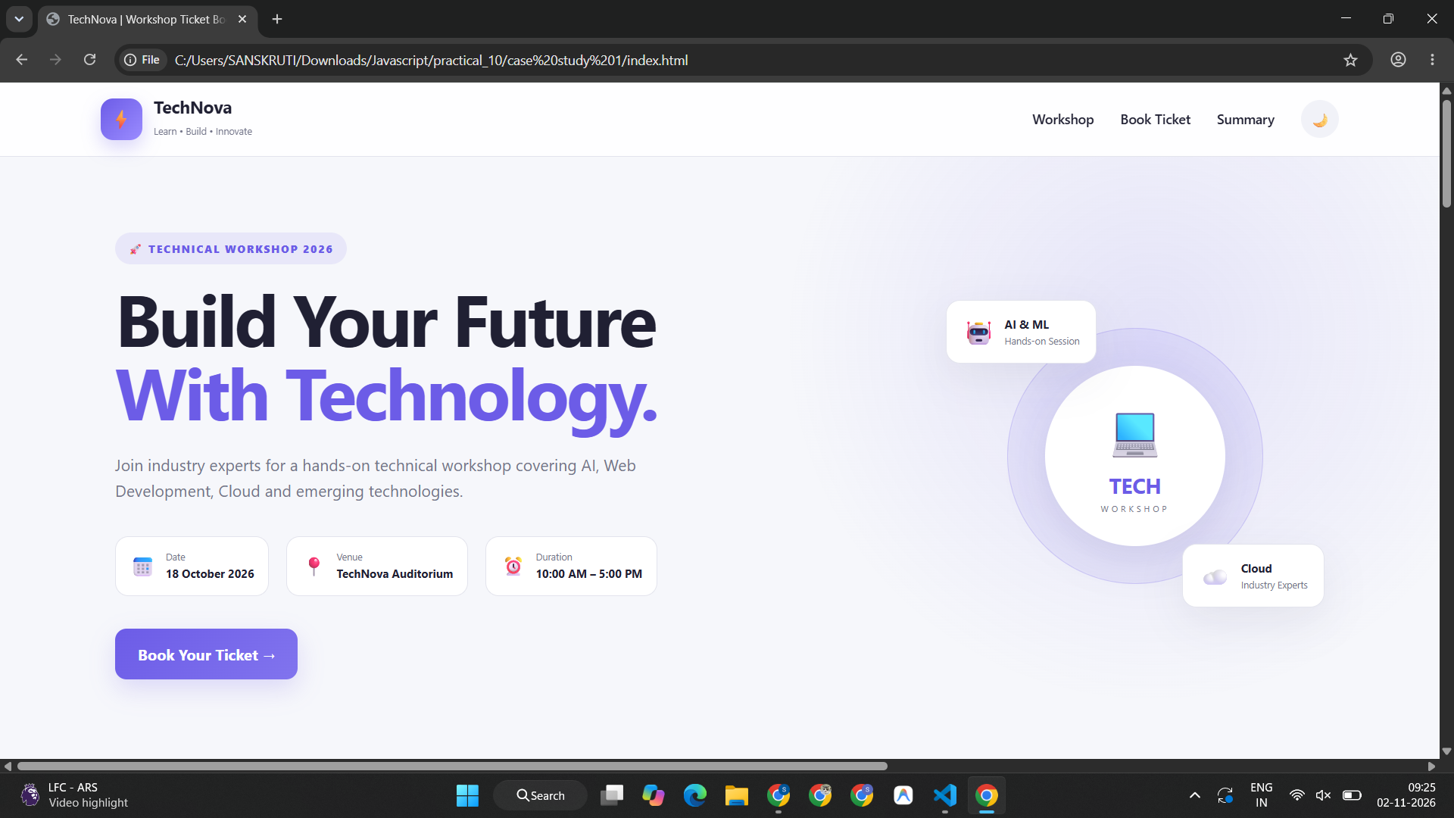
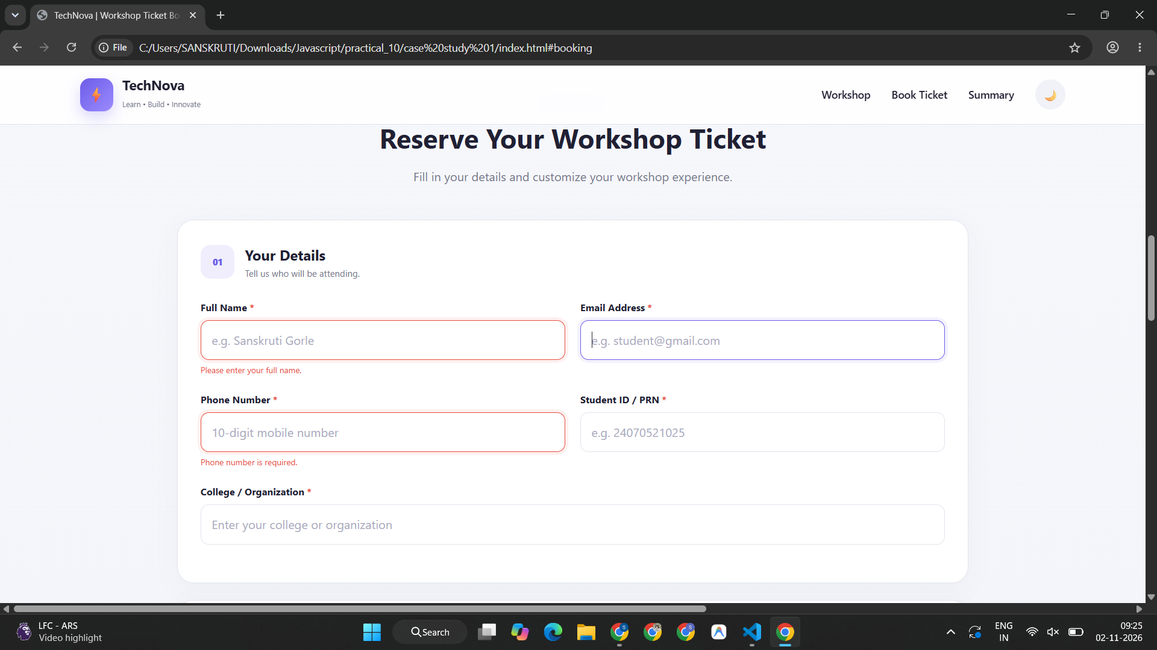
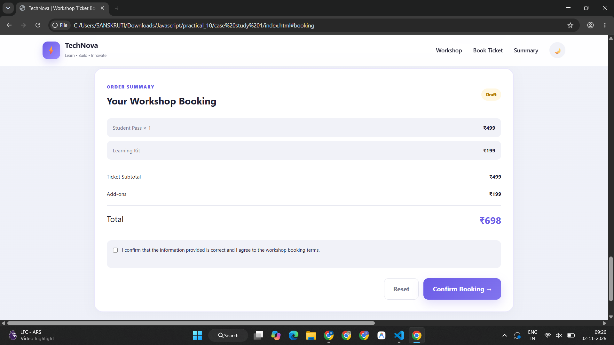
Additional Module 1: Smart India Hackathon (SIH) Information Portal
index.html
<!DOCTYPE html>
<html lang="en">
<head>
<meta charset="UTF-8">
<meta name="viewport" content="width=device-width, initial-scale=1.0">

<title>Smart India Hackathon</title>

<link rel="stylesheet" href="style.css">
</head>
<body>

<!-- Header -->
<header>
<h1>SMART INDIA HACKATHON</h1>
<p>Innovate | Create | Solve</p>
</header>

<!-- Navigation Bar -->
<nav>
<a href="#home">Home</a>
<a href="#about">About</a>
<a href="#achievements">Achievements</a>
<a href="#opportunities">Opportunities</a>
</nav>

<!-- Home Section -->
<section id="home">
<h2>Welcome to Smart India Hackathon</h2>

<p>
Smart India Hackathon (SIH) is a nationwide initiative
that encourages students to develop innovative solutions
to real-world problems.
</p>

<p>
It promotes <b>innovation</b>, <i>creativity</i> and
<u>teamwork</u> among students.
</p>

<button id="welcomeBtn">Click for Welcome Message</button>
</section>

<hr>

<!-- About Section -->
<section id="about">
<h2>About SIH</h2>

<p>
Smart India Hackathon provides students with a platform
to solve challenges presented by organizations and
government departments.
</p>

<h3>Major Objectives</h3>

<ul>
<li>Encourage innovative thinking.</li>
<li>Develop technical and programming skills.</li>
<li>Promote teamwork and collaboration.</li>
<li>Solve real-world challenges.</li>
</ul>
</section>

<hr>

<!-- Achievements Section -->
<section id="achievements">
<h2>Achievements and Benefits</h2>

<p>Participating in hackathons helps students to:</p>

<ul>
<li>Gain practical project experience.</li>
<li>Improve problem-solving abilities.</li>
<li>Build technical portfolios.</li>
<li>Collaborate with students from different institutions.</li>
</ul>

<p class="highlight">
Learn new skills, share ideas and turn innovative concepts
into practical solutions!
</p>
</section>

<hr>

<!-- Opportunities Section -->
<section id="opportunities">
<h2>Career Opportunities</h2>

<p>
Hackathon experience can help students develop skills
useful for internships, projects and future employment.
</p>

<p>
<b>Important Skills:</b><br>
Programming<br>
Problem Solving<br>
Teamwork<br>
Innovation
</p>
</section>

<!-- Footer -->
<footer>
<p>&copy; 2026 Smart India Hackathon Information Page</p>
<p id="date"></p>
</footer>

<script src="script.js"></script>

</body>
</html>
style.css
* {
box-sizing: border-box;
}

body {
margin: 0;
font-family: Arial, sans-serif;
background-color: #f1f5fc;
color: #333;
line-height: 1.6;
}

/* Header */
header {
background-color: #123b70;
color: white;
text-align: center;
padding: 30px 15px;
}

header h1 {
font-size: 32px;
margin: 0;
}

header p {
font-size: 18px;
margin-bottom: 0;
}

/* Navigation */
nav {
background-color: #f28c28;
text-align: center;
padding: 14px;
}

nav a {
color: white;
text-decoration: none;
font-weight: bold;
margin: 0 15px;
}

nav a:hover {
color: #123b70;
text-decoration: underline;
}

/* Content Sections */
section {
max-width: 900px;
margin: 22px auto;
padding: 25px;
background-color: white;
border-radius: 8px;
box-shadow: 0 3px 10px rgba(0, 0, 0, 0.06);
}

h2 {
color: #123b70;
border-bottom: 2px solid #f28c28;
padding-bottom: 8px;
}

h3 {
color: #d66b12;
}

p {
text-align: justify;
}

li {
margin-bottom: 8px;
}

hr {
max-width: 900px;
border: none;
height: 2px;
background-color: #d5deeb;
}

.highlight {
color: #d66b12;
font-weight: bold;
}

/* Button */
button {
background-color: #123b70;
color: white;
padding: 12px 18px;
border: none;
border-radius: 5px;
cursor: pointer;
}

button:hover {
background-color: #f28c28;
}

/* Footer */
footer {
background-color: #123b70;
color: white;
text-align: center;
padding: 15px;
margin-top: 25px;
}

footer p {
text-align: center;
margin: 5px;
}

/* Responsive Design */
@media (max-width: 600px) {
header h1 {
font-size: 24px;
}

nav a {
display: inline-block;
margin: 5px 8px;
}

section {
margin: 12px;
padding: 18px;
}

hr {
margin: 15px;
}
}
script.js
// Welcome message button
const welcomeBtn = document.getElementById("welcomeBtn");

welcomeBtn.addEventListener("click", function () {
alert("Welcome to Smart India Hackathon! Keep Innovating!");
});

// Navigation link interaction
const navLinks = document.querySelectorAll("nav a");

navLinks.forEach(function (link) {
link.addEventListener("click", function () {
console.log("Selected section: " + link.textContent);
});
});

// Display current date in the footer
const dateElement = document.getElementById("date");

const today = new Date();

dateElement.textContent =
"Today's Date: " + today.toLocaleDateString();
Output –
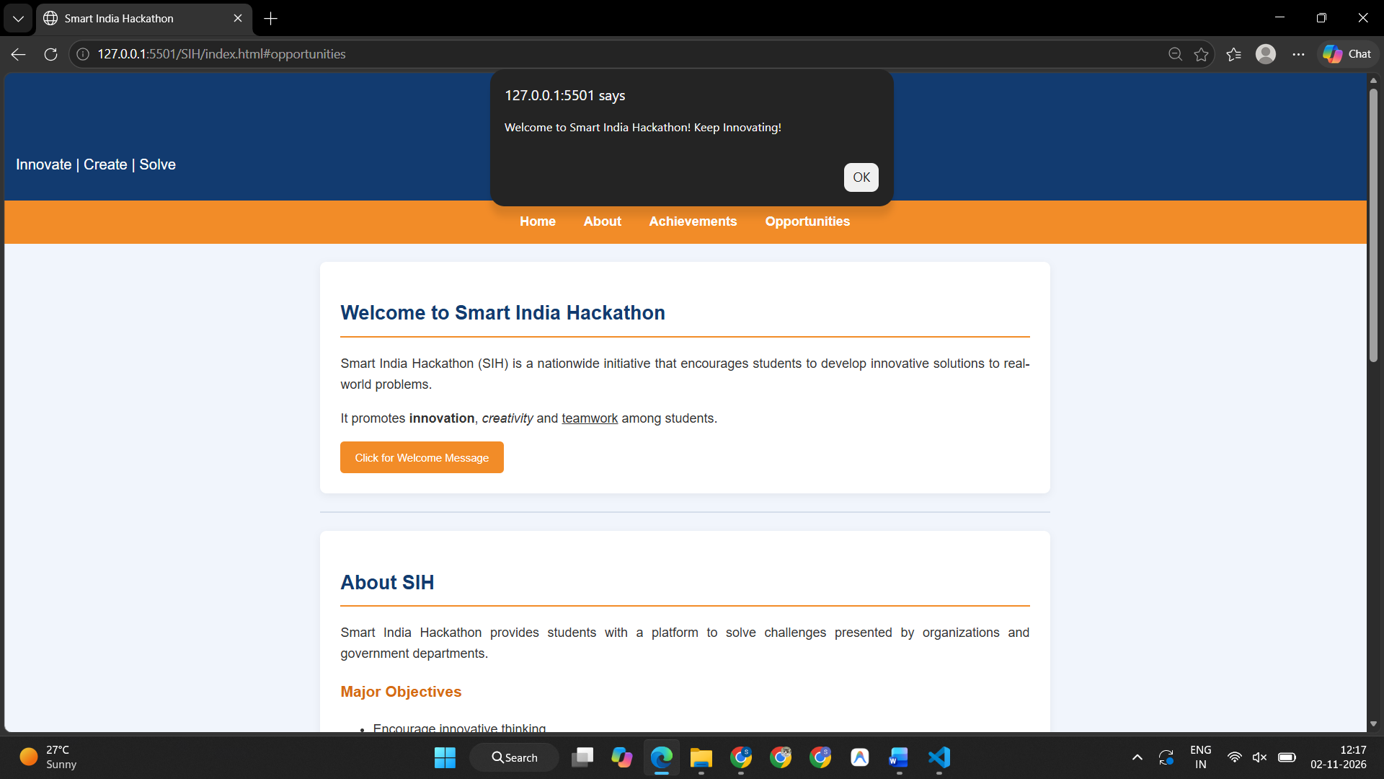
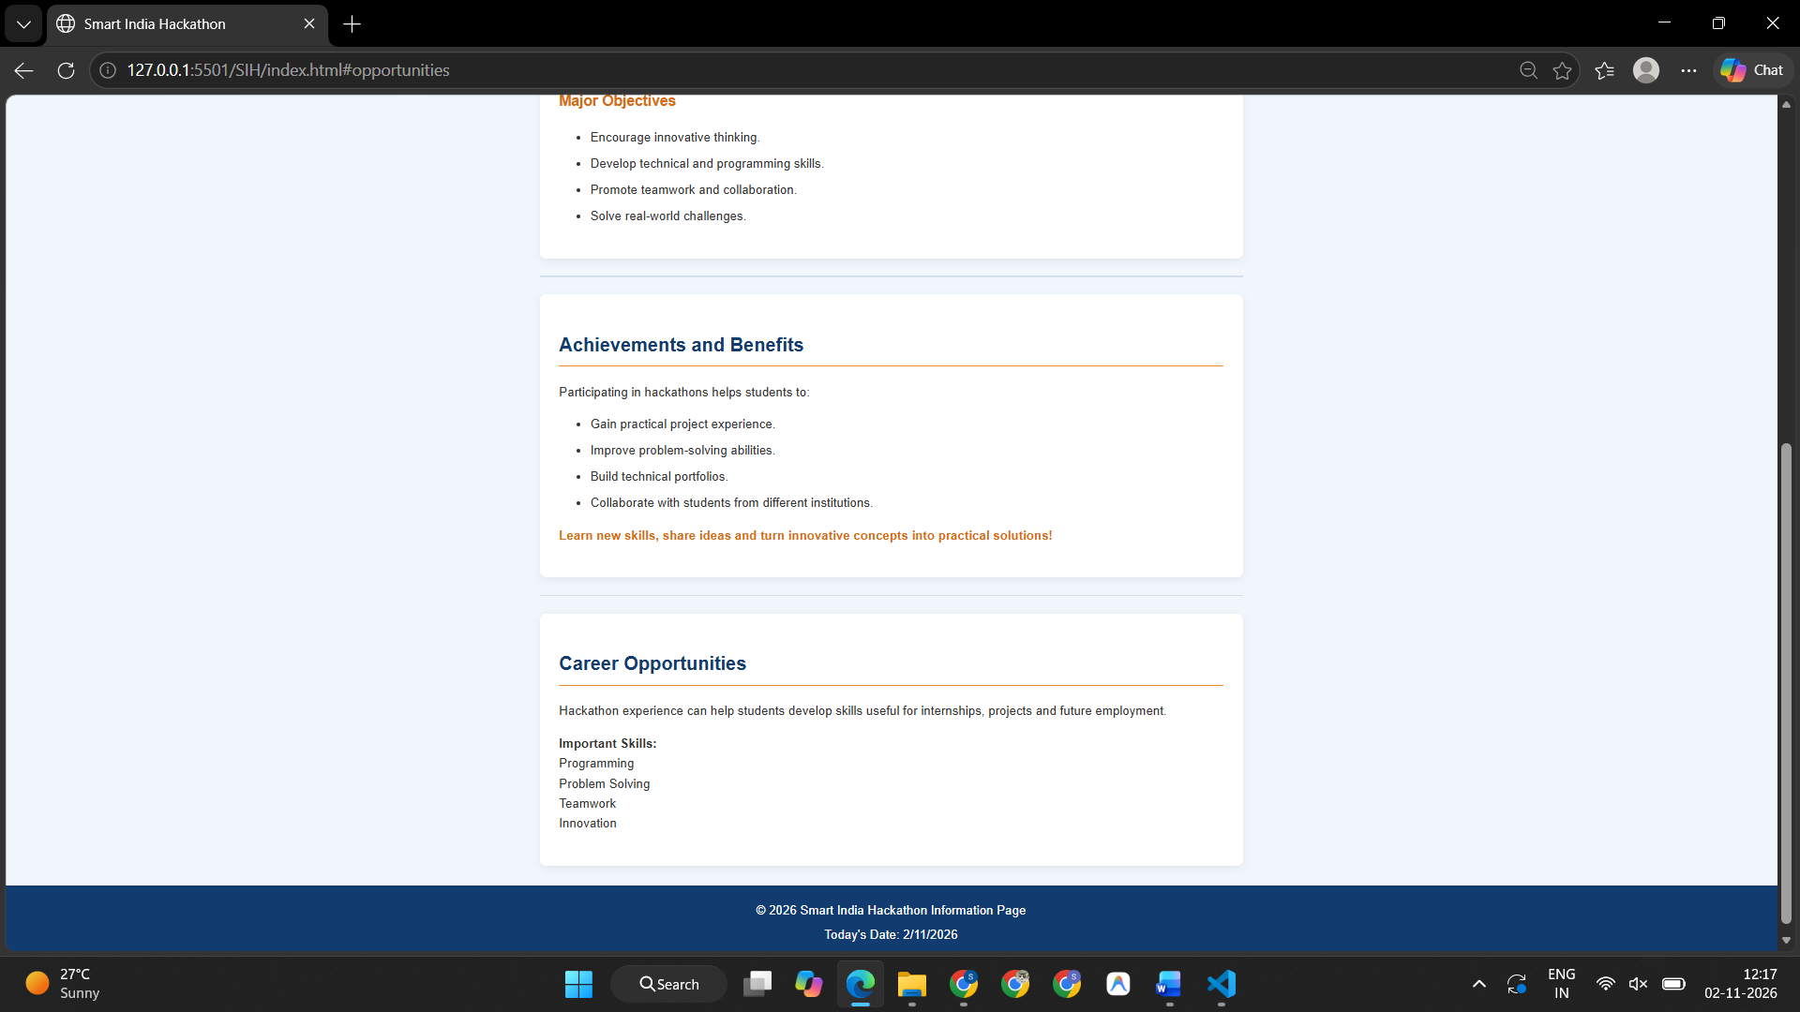
Additional Module 2: Rakhi World E-Commerce Store & Interactive Cart
index.html
<!DOCTYPE html>
<html lang="en">
<head>
<meta charset="UTF-8">
<meta name="viewport" content="width=device-width, initial-scale=1.0">

<title>Rakhi World | Celebrate the Bond</title>

<link rel="stylesheet" href="style.css">
</head>
<body>

<!-- Header -->
<header class="header">
<div class="logo">Rakhi<span>World</span></div>

<p>Celebrating the Bond of Love ❤️</p>

<div class="cart">
🛍️ Cart: <span id="cartCount">0</span>
</div>
</header>

<!-- Navigation -->
<nav>
<a href="#home">Home</a>
<a href="#products">Shop Rakhis</a>
<a href="#about">About Us</a>
<a href="#contact">Contact</a>
</nav>

<!-- Hero Section -->
<section id="home" class="hero">
<div class="hero-content">
<p class="tagline">A FESTIVAL OF LOVE</p>

<h1>Make Every Bond<br>More Beautiful</h1>

<p>
Discover beautiful rakhis that express love,
care and the special bond between siblings.
</p>

<a href="#products" class="shop-btn">Explore Collection →</a>
</div>

<div class="hero-decoration">
🎁
<span>Special Gifts, Special Bonds</span>
</div>
</section>

<!-- Product Section -->
<section id="products" class="products-section">

<div class="section-heading">
<p class="tagline">HANDPICKED WITH LOVE</p>
<h2>Our Rakhi Collection</h2>
<p>Find the perfect rakhi for your favourite person.</p>
</div>

<div class="product-container">

<!-- Floral Rakhi -->
<div class="product">
<div class="product-image">
<img src="./assets/Floral Rakhi with Kumkum Accents.png"
alt="Pink floral rakhi">
<span class="badge">POPULAR</span>
</div>

<div class="product-info">
<p class="category">FLORAL COLLECTION</p>
<h3>Floral Rakhi</h3>
<p class="description">
A delicate floral design with beautiful pink petals.
</p>

<div class="price">₹99</div>

<button class="buy-btn">Add to Cart</button>
</div>
</div>

<!-- Designer Rakhi -->
<div class="product">
<div class="product-image">
<img src="./assets/Ornate Red Gemstone Rakhi on Silk.png"
alt="Blue gemstone designer rakhi">
<span class="badge">PREMIUM</span>
</div>

<div class="product-info">
<p class="category">DESIGNER COLLECTION</p>
<h3>Designer Rakhi</h3>
<p class="description">
An elegant blue gemstone rakhi with golden detailing.
</p>

<div class="price">₹149</div>

<button class="buy-btn">Add to Cart</button>
</div>
</div>

<!-- Traditional Rakhi -->
<div class="product">
<div class="product-image">
<img src="./assets/Traditional Red and Gold Rakhi Still Life.png"
alt="Traditional red and gold Om rakhi">
<span class="badge">TRADITIONAL</span>
</div>

<div class="product-info">
<p class="category">CLASSIC COLLECTION</p>
<h3>Traditional Rakhi</h3>
<p class="description">
A traditional red and gold rakhi with an Om design.
</p>

<div class="price">₹79</div>

<button class="buy-btn">Add to Cart</button>
</div>
</div>

<!-- Premium Rakhi -->
<div class="product">
<div class="product-image">
<img src="./assets/Elegant Blue Gemstone Rakhi Setup.png"
alt="Premium Ganesha rakhi">
<span class="badge">EXCLUSIVE</span>
</div>

<div class="product-info">
<p class="category">LUXURY COLLECTION</p>
<h3>Premium Rakhi</h3>
<p class="description">
A beautiful Ganesha rakhi with rich red and gold details.
</p>

<div class="price">₹199</div>

<button class="buy-btn">Add to Cart</button>
</div>
</div>

</div>
</section>

<!-- Features -->
<section class="features">
<div>
<span>🎀</span>
<h3>Beautiful Designs</h3>
<p>Special designs for every sibling.</p>
</div>

<div>
<span>🎁</span>
<h3>Gift with Love</h3>
<p>Make your celebration memorable.</p>
</div>

<div>
<span>💝</span>
<h3>Made for Family</h3>
<p>Celebrate your unbreakable bond.</p>
</div>
</section>

<!-- About -->
<section id="about" class="info-section">
<h2>About Rakhi World</h2>

<p>
Rakhi World brings you a carefully selected collection
of traditional, floral, designer and premium rakhis.
Our aim is to make every Raksha Bandhan special through
beautiful designs and meaningful gifts.
</p>
</section>

<!-- Contact -->
<section id="contact" class="info-section contact">
<h2>Contact Us</h2>
<p>Email: support@rakhiworld.example</p>
<p>Phone: +91 98765 43210</p>
</section>

<!-- Footer -->
<footer>
<h2>Rakhi World</h2>
<p>Celebrating love, one rakhi at a time. ❤️</p>
<p>© <span id="year"></span> Rakhi World. All rights reserved.</p>
</footer>

<script src="script.js"></script>

</body>
</html>
style.css
* {
box-sizing: border-box;
margin: 0;
padding: 0;
}

html {
scroll-behavior: smooth;
}

body {
font-family: Arial, sans-serif;
background: #fffaf7;
color: #3e2928;
line-height: 1.6;
}

/* Header */
.header {
min-height: 100px;
padding: 18px 5%;
display: flex;
align-items: center;
justify-content: space-between;
gap: 20px;
flex-wrap: wrap;
background: white;
}

.logo {
font-size: 30px;
font-weight: bold;
color: #a83250;
}

.logo span {
color: #d59b47;
}

.header p {
color: #765957;
}

.cart {
padding: 10px 16px;
border: 1px solid #ead4d5;
border-radius: 25px;
font-weight: bold;
}

/* Navigation */
nav {
background: #7f203a;
padding: 15px 5%;
display: flex;
justify-content: center;
gap: 45px;
flex-wrap: wrap;
}

nav a {
color: white;
text-decoration: none;
font-weight: bold;
}

nav a:hover {
color: #ffd6a5;
}

/* Hero Section */
.hero {
min-height: 380px;
padding: 65px 8%;
display: flex;
justify-content: space-between;
align-items: center;
gap: 40px;
background: linear-gradient(120deg, #ffe8e8, #fff1dc);
}

.hero-content {
max-width: 650px;
}

.tagline {
color: #a83250;
font-size: 12px;
font-weight: bold;
letter-spacing: 2px;
}

.hero h1 {
font-size: clamp(32px, 4vw, 52px);
line-height: 1.2;
margin: 15px 0;
color: #7f203a;
}

.hero-content > p:not(.tagline) {
max-width: 520px;
margin-bottom: 25px;
color: #715553;
}

.shop-btn {
display: inline-block;
background: #a83250;
color: white;
padding: 13px 24px;
border-radius: 5px;
text-decoration: none;
font-weight: bold;
}

.shop-btn:hover {
background: #7f203a;
}

.hero-decoration {
width: 280px;
height: 220px;
flex-shrink: 0;
border-radius: 50%;
background: rgba(255, 255, 255, 0.65);
display: flex;
flex-direction: column;
justify-content: center;
align-items: center;
font-size: 85px;
color: #a83250;
}

.hero-decoration span {
font-size: 13px;
font-weight: bold;
text-align: center;
}

/* Products */
.products-section {
padding: 65px 5%;
}

.section-heading {
text-align: center;
margin-bottom: 40px;
}

.section-heading h2 {
color: #7f203a;
font-size: 34px;
margin: 8px 0;
}

.section-heading > p:last-child {
color: #806b68;
}

/* Wide product layout */
.product-container {
width: 100%;
display: grid;
grid-template-columns: repeat(4, minmax(0, 1fr));
gap: 24px;
}

/* Product Cards */
.product {
min-width: 0;
overflow: hidden;
background: white;
border: 1px solid #f0dfe0;
border-radius: 10px;
transition: transform 0.25s, box-shadow 0.25s;
}

.product:hover {
transform: translateY(-5px);
box-shadow: 0 10px 25px rgba(100, 30, 50, 0.12);
}

.product-image {
position: relative;
height: 250px;
background: #f9eee8;
overflow: hidden;
}

.product-image img {
width: 100%;
height: 100%;
object-fit: cover;
display: block;
transition: transform 0.35s;
}

.product:hover .product-image img {
transform: scale(1.04);
}

.badge {
position: absolute;
top: 12px;
left: 12px;
padding: 5px 9px;
border-radius: 4px;
background: #a83250;
color: white;
font-size: 10px;
font-weight: bold;
}

.product-info {
padding: 20px;
}

.category {
font-size: 10px;
letter-spacing: 1px;
color: #a83250;
font-weight: bold;
}

.product-info h3 {
margin: 7px 0;
font-size: 20px;
color: #452b2d;
}

.description {
min-height: 65px;
font-size: 13px;
color: #806b68;
}

.price {
margin: 12px 0;
font-size: 23px;
font-weight: bold;
color: #a83250;
}

.buy-btn {
width: 100%;
padding: 12px;
background: #a83250;
color: white;
border: none;
border-radius: 5px;
cursor: pointer;
font-size: 14px;
font-weight: bold;
}

.buy-btn:hover {
background: #7f203a;
}

/* Features */
.features {
display: grid;
grid-template-columns: repeat(3, 1fr);
gap: 25px;
padding: 40px 8%;
background: #fff0ec;
text-align: center;
}

.features span {
font-size: 35px;
}

.features h3 {
margin: 8px 0;
color: #7f203a;
}

.features p {
color: #806b68;
font-size: 14px;
}

/* About and Contact */
.info-section {
max-width: 1000px;
margin: 0 auto;
padding: 45px 30px;
text-align: center;
}

.info-section h2 {
color: #7f203a;
margin-bottom: 15px;
}

.info-section p {
color: #715e5c;
}

.contact {
padding-top: 15px;
}

/* Footer */
footer {
background: #7f203a;
color: white;
text-align: center;
padding: 28px 15px;
}

footer h2 {
margin-bottom: 5px;
}

footer p {
margin: 5px 0;
font-size: 14px;
}

/* Responsive Design */
@media (max-width: 1100px) {
.product-container {
grid-template-columns: repeat(2, minmax(0, 1fr));
}

.product-image {
height: 280px;
}

.hero-decoration {
width: 220px;
height: 190px;
}
}

@media (max-width: 600px) {
.header {
justify-content: center;
text-align: center;
flex-direction: column;
}

nav {
gap: 15px;
padding: 15px 10px;
}

nav a {
font-size: 13px;
}

.hero {
padding: 45px 22px;
}

.hero-decoration {
display: none;
}

.hero h1 {
font-size: 34px;
}

.products-section {
padding: 40px 15px;
}

.section-heading h2 {
font-size: 27px;
}

.product-container {
grid-template-columns: 1fr;
gap: 20px;
}

.product-image {
height: 300px;
}

.features {
grid-template-columns: 1fr;
}
}
script.js
// Select all product buttons
const buyButtons = document.querySelectorAll(".buy-btn");

let cartCount = 0;

// Add event to every product button
buyButtons.forEach(function (button) {

button.addEventListener("click", function () {

const product = button.closest(".product");

const productName =
product.querySelector("h3").textContent;

const productPrice =
product.querySelector(".price").textContent;

cartCount++;

document.getElementById("cartCount").textContent =
cartCount;

alert(
productName + " added to your cart!\n" +
"Price: " + productPrice + "\n" +
"Items in cart: " + cartCount
);

});

});

// Display current year automatically
document.getElementById("year").textContent =
new Date().getFullYear();

// Log a message in the console
console.log("Welcome to Rakhi World!");
Output –
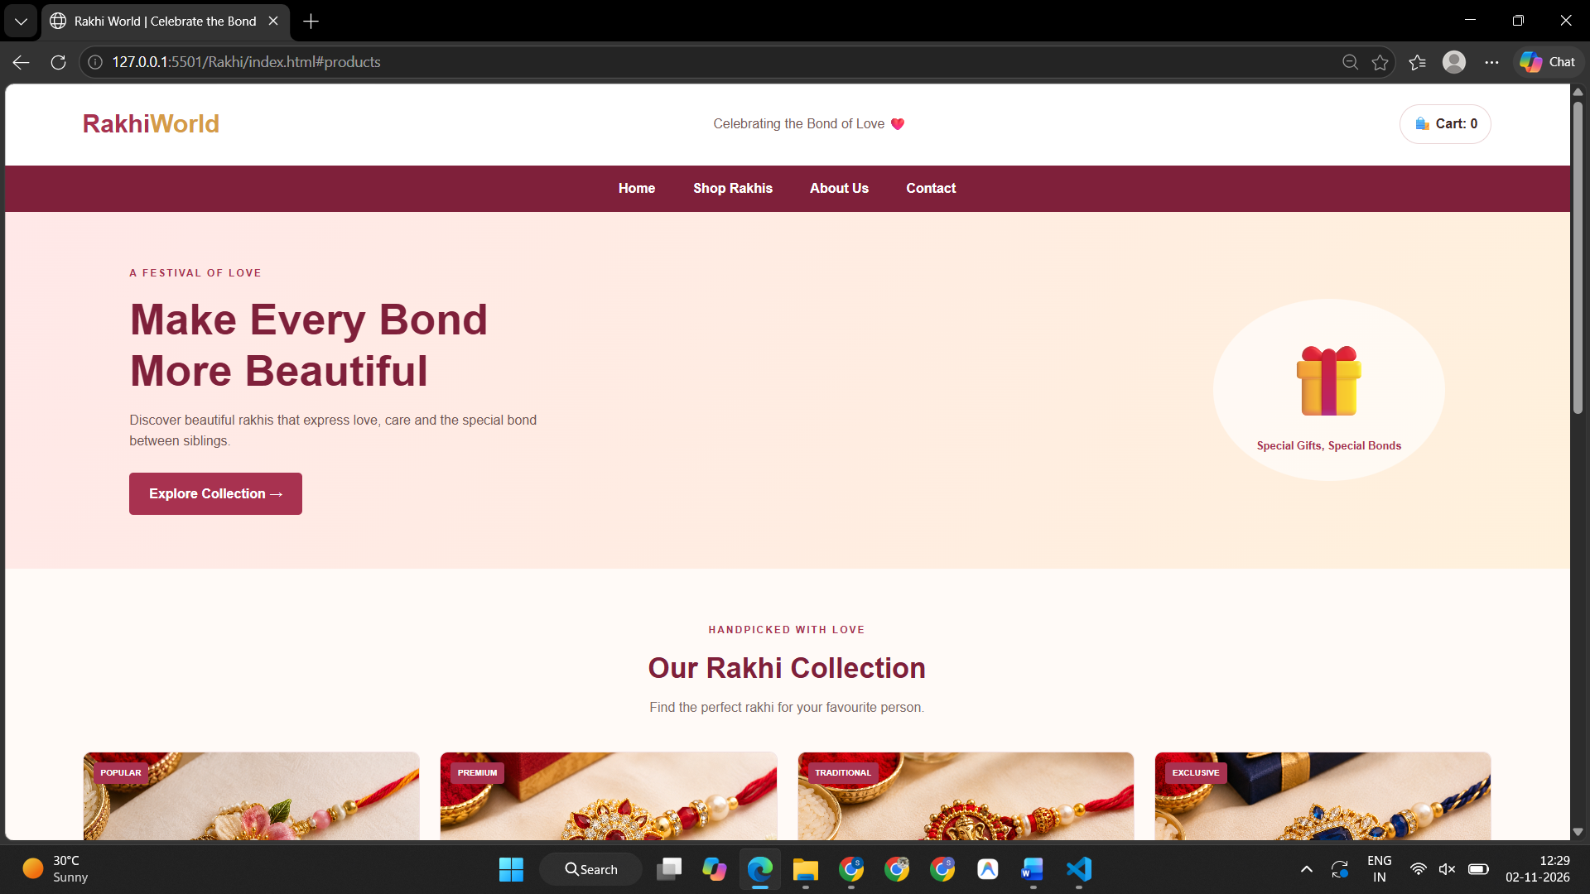
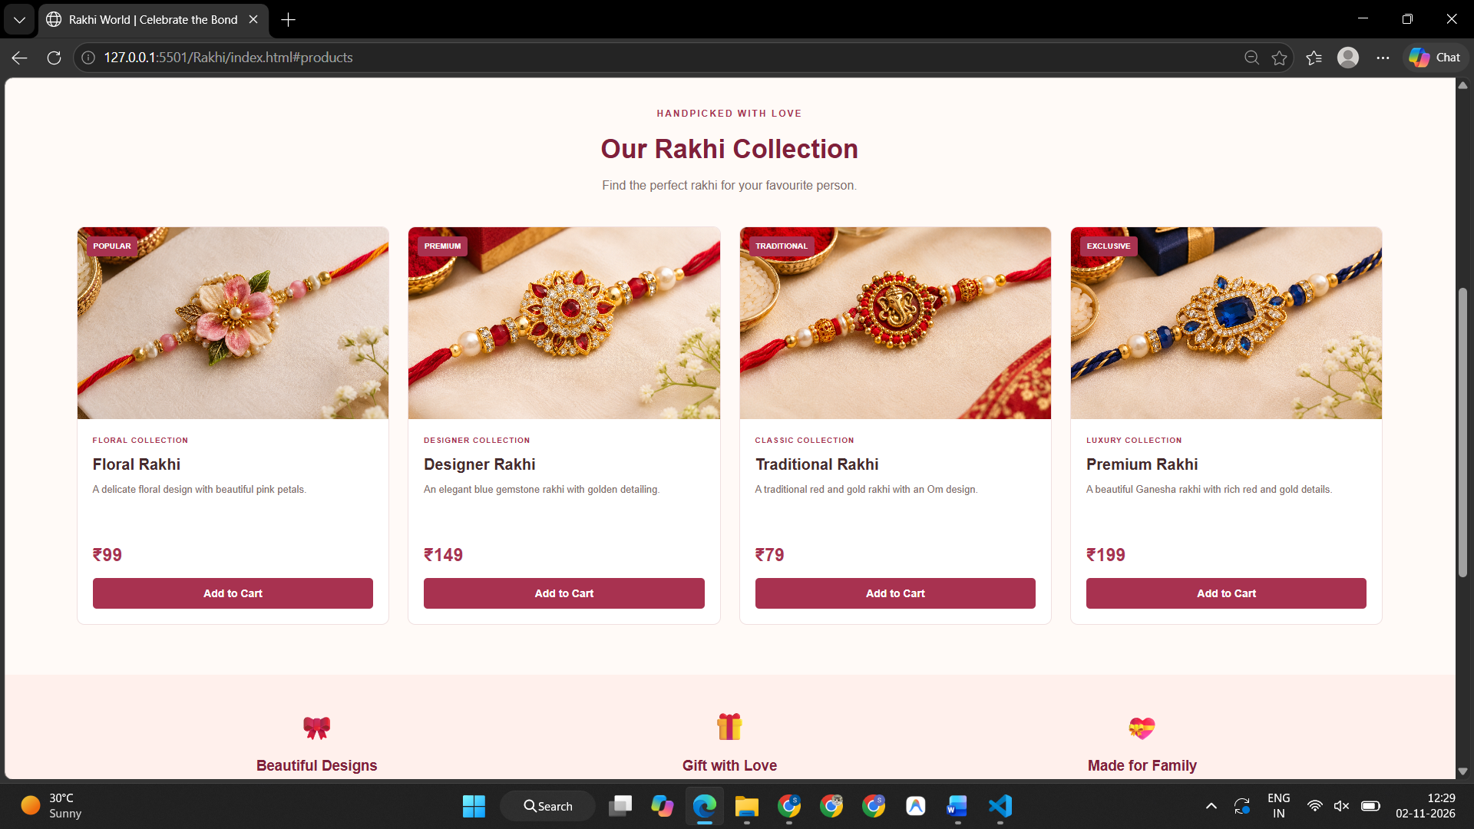
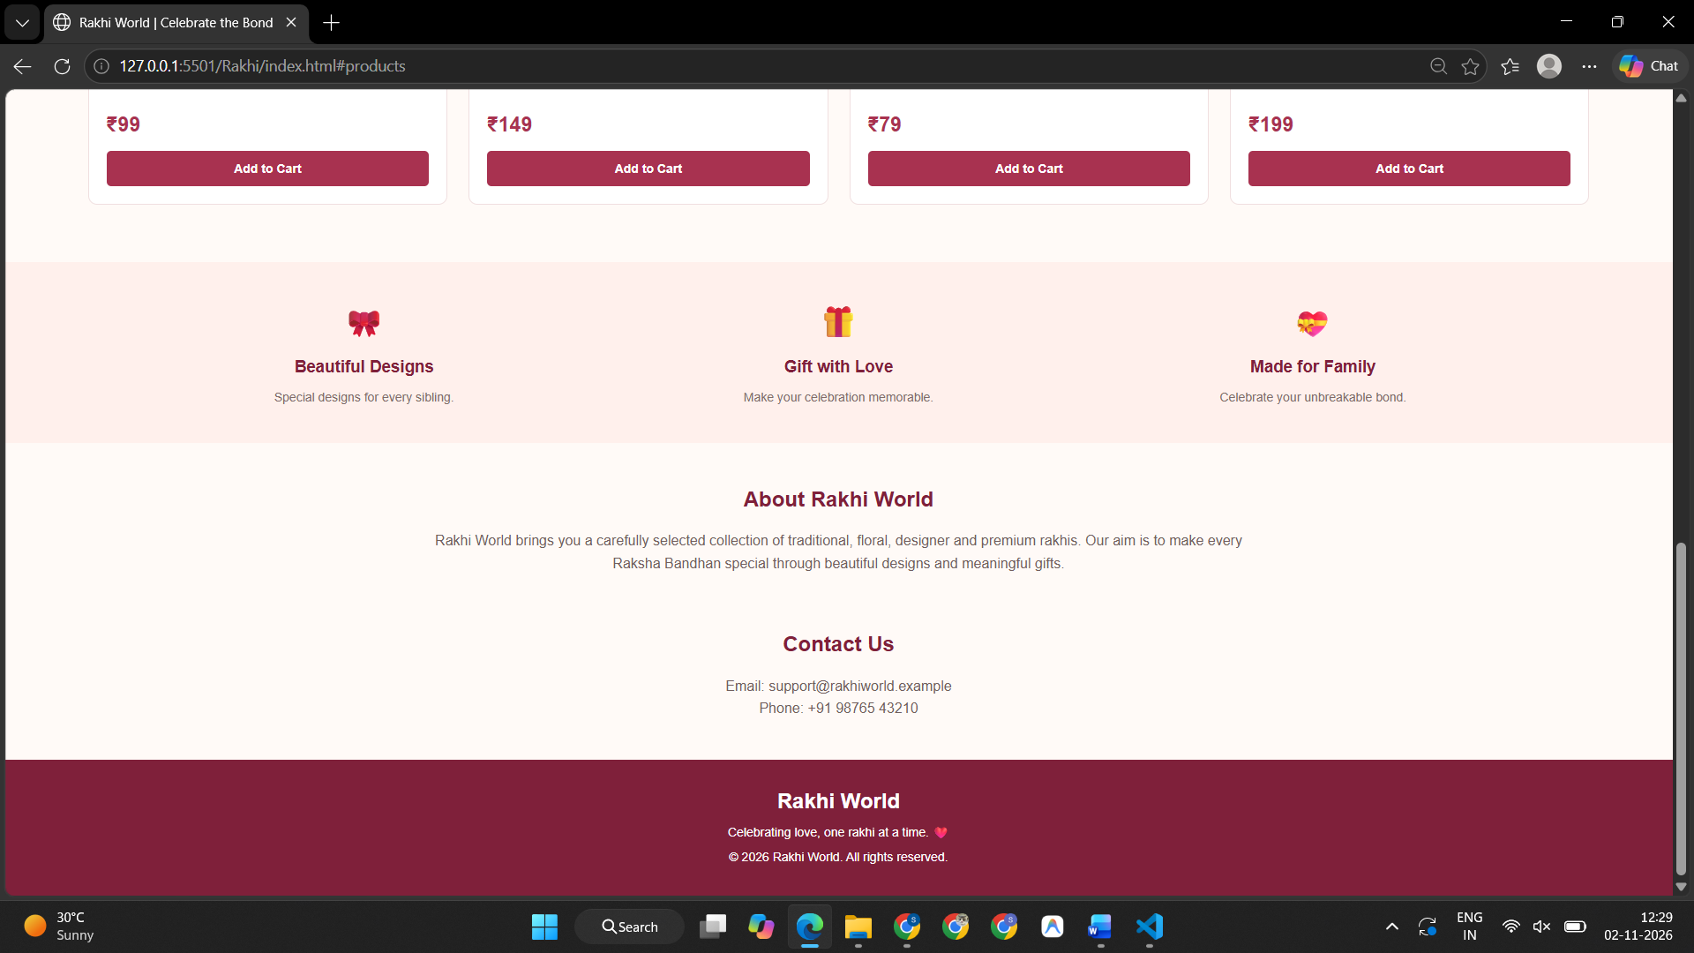
Conclusion –
In this experiment, JavaScript timing functions (setInterval, setTimeout, clearInterval) and ES6 modular programming (import/export) were thoroughly understood and implemented. An interactive Countdown Timer and Class Scheduler was successfully created with dynamic state updates. Furthermore, Case Study 1 (TechNova Workshop Booking) demonstrated comprehensive ticket calculation, coupon code application, live DOM feedback, and form validation. The Smart India Hackathon (SIH) portal and Rakhi World e-commerce showcase further highlighted interactive event handling, dialog alerts, and dynamic product cart tracking. All applications were tested and verified successfully in the browser.

